RENTAL DETAILS
7th Floor Office – Vacant Premises (Class E)
To Let – c.7,015 sq ft (651.7 sq m)
(A possible further c.3,500 sq ft available – see below for detail)

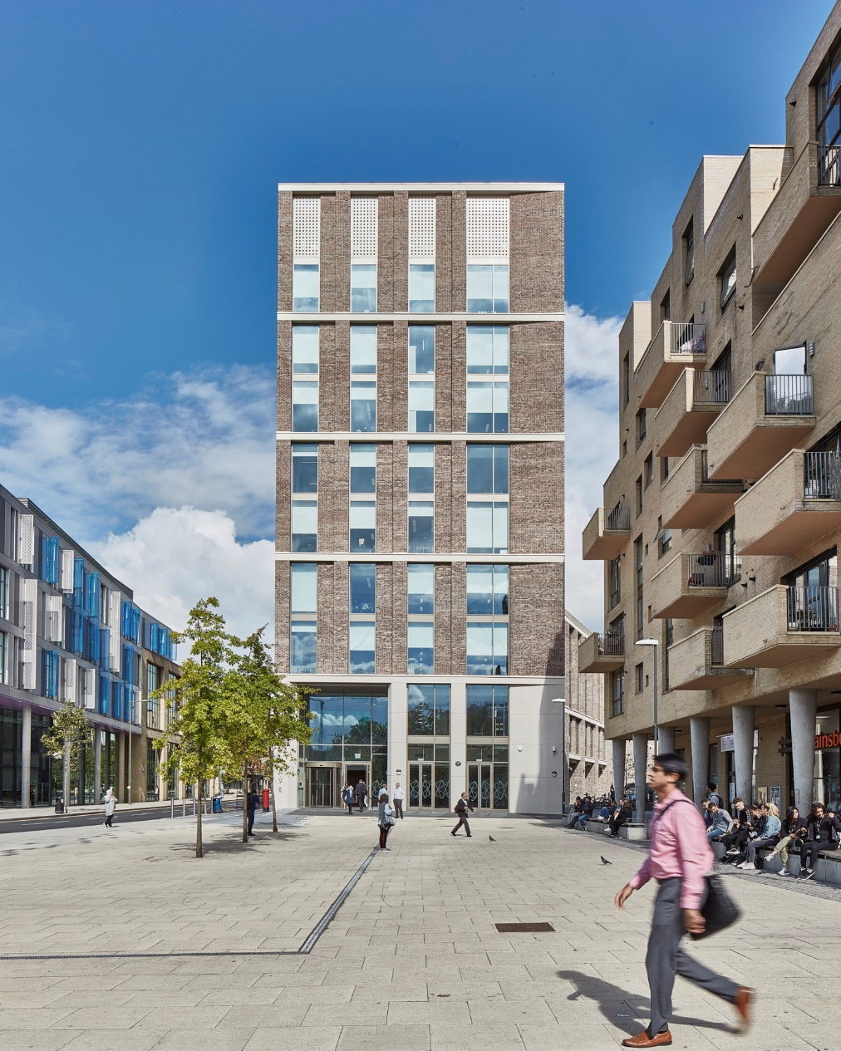
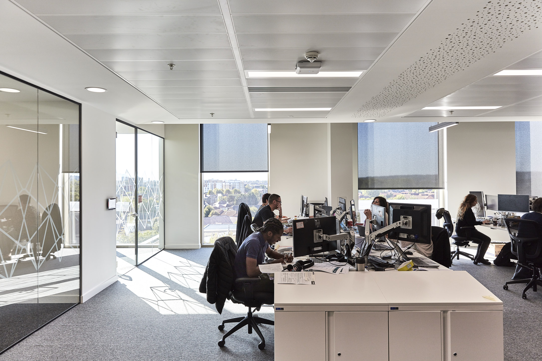
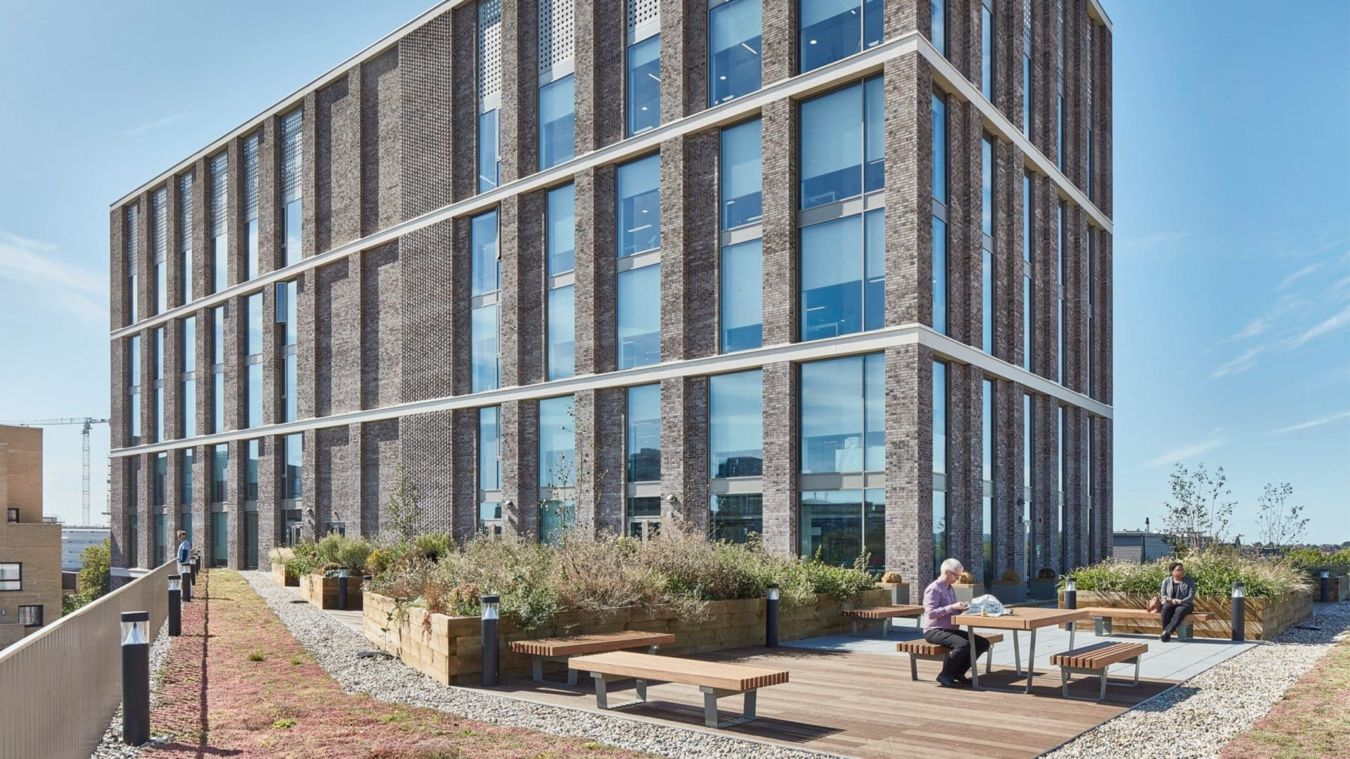
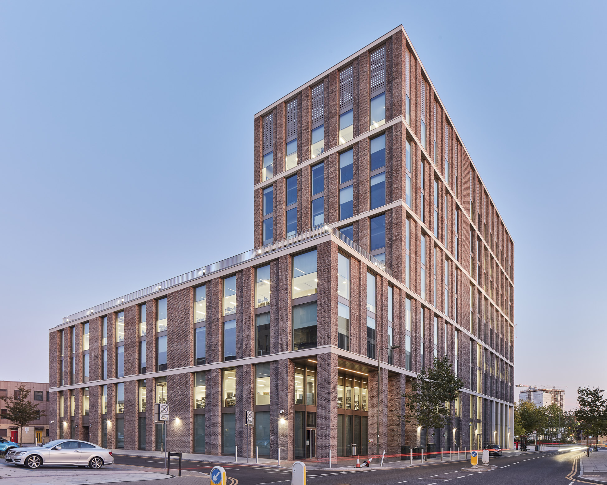
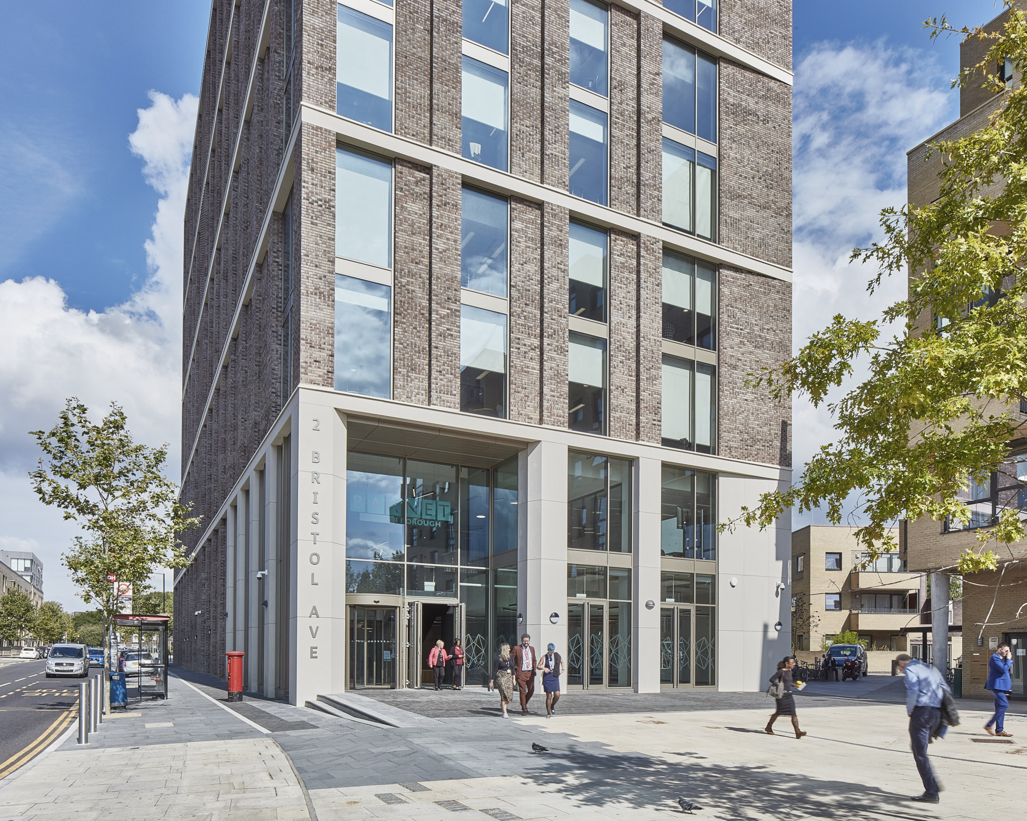
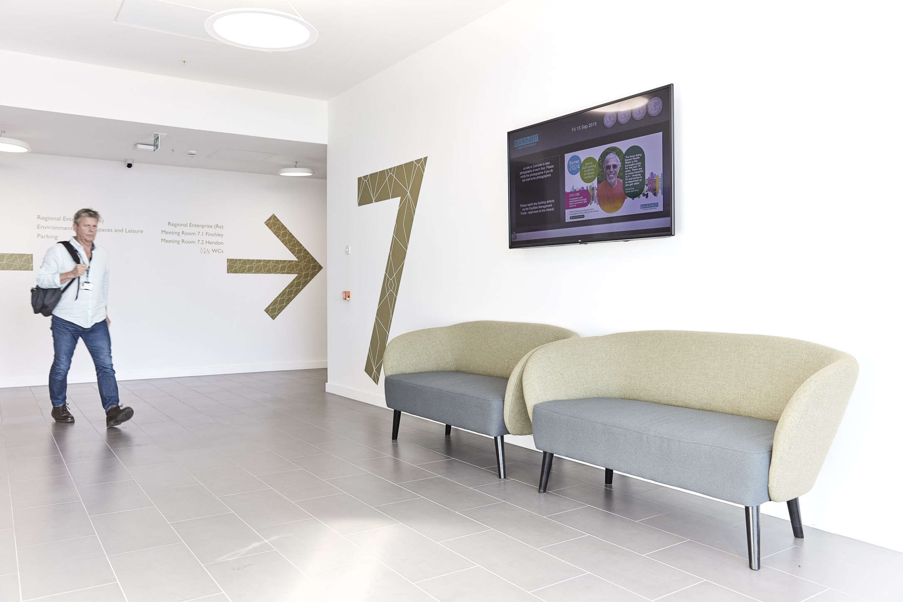

2 Bristol Avenue, Colindale, Barnet, NW9 4EW
*Modern Office Space to Let*

Location

Approximately five minutes’ walk from Colindale Underground station, on Bristol Avenue, just off Grahame Park Way. Located in Zone 4 of the London Underground network, Colindale is on the Edgware branch of the Northern Line, feeding into both central London and the City of London in under 20 minutes. It is also close to new development areas such as Brent Cross Cricklewood, where new homes and jobs are being created as part of one of the biggest regeneration schemes in London.

The immediate area has seen significant residential development and regeneration in recent years and provides several green spaces including parks and recreational areas. It is well located, offering easy travel into the centre of London, while also conveniently located for access to the northern Home Counties.

Colindale is some 7 miles from junction 23 of the M25 while the M1 and A406 are easily accessible from the town centre itself, allowing east-west and north-south access in and out of London. The area is also well-served by an extensive bus network, providing good connectivity across the wider London area with the 226 bus providing direct access into central London.

There is a diverse range of shops and restaurants, including Brent Cross Shopping Centre, within easy reach as well as leisure and gym facilities.

A location plan can be found in Appendix 1.

Lettable area description
The entire 7th floor of a modern and highly specified 2019 headquarters building. The office has a BREEAM rating of “Very Good” and benefits from full access raised floors, VRV air conditioning, 3x 21 person lifts and unisex WC facilities on each floor.
The 7th floor comprises c.7,015 sq ft (651.7 sq m) of office space and is the primary accommodation to be made available. Note: there may also be potential for a further c.3,500 sq ft on floor 6, thereby offering up to c.10,065 sq ft of combined available floor space. The entire space may be provided in whole or part. Further detail on request.
The rest of the building is shared with the local authority and another major company – Ingeus – who currently rent the 8th floor. On the ground floor, there is a busy café that provides a range of hot and cold drinks and an extensive menu of meals and snacks, which is open to building users and members of the public.
See appendix 2.

Planning
The property use is class E under the Town and Country Planning (Use classes) Act.
Interested parties are requested to make their own enquiries of Barnet Council’s Local Planning Authority (020 8359 4974)

Rental terms
Rent £195,000 per annum for the 7th floor. Based on a ten-year FRI lease, subject to a mutual break option at year five.

The forecast service charge and business rates payable for the forthcoming year is in the order of £190,939. Further detail on request.

Costs
The prospective tenant will be responsible for the council’s legal and surveyor’s fees.

Further Information please contact:
Barnet Estates/Property Services | Tel: 020 8359 3999  Email: Business.Space@barnet.gov.uk
General Information
1. The areas and measurements contained within these particulars are approximate figures only and no warranty is given as to their accuracy. The prospective tenants should satisfy themselves as to site areas and other matters of measurement from their own inspections and surveys. These details do not form part of any contract.
2. All statements made herein are made without responsibility on the part of the London Borough of Barnet and its employees and should not be relied upon as statements or representations of fact. Prospective tenants must satisfy themselves by inspection or otherwise as to the correctness of each of the statements contained in these particulars.
3. The London Borough of Barnet and its employees do not give any warranty whatsoever in relation to the property.
4. The property will be leased as seen with all latent and patent defects and neither the London Borough of Barnet nor its employees warrant that it is suitable for any proposed use.
5. In no case shall any prospective tenant have any claim for expenses incurred in the preparation of any offer, nor in respect of any other matter.
6. The Council is not obliged to accept the highest or any offer received.

Appendix 1

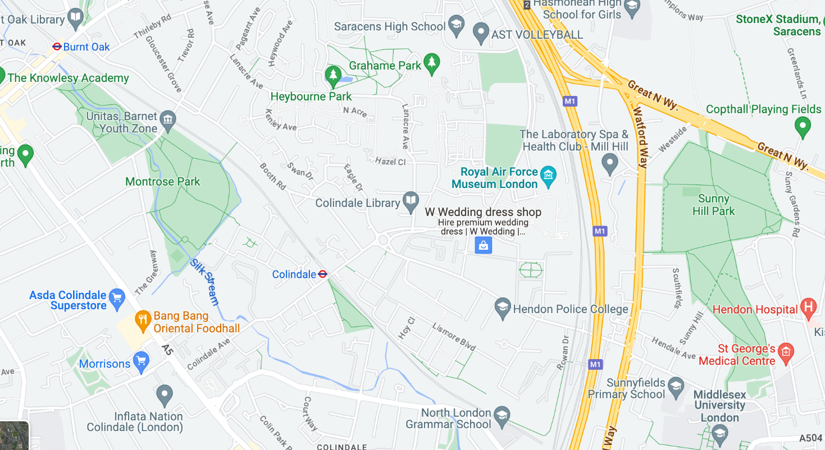

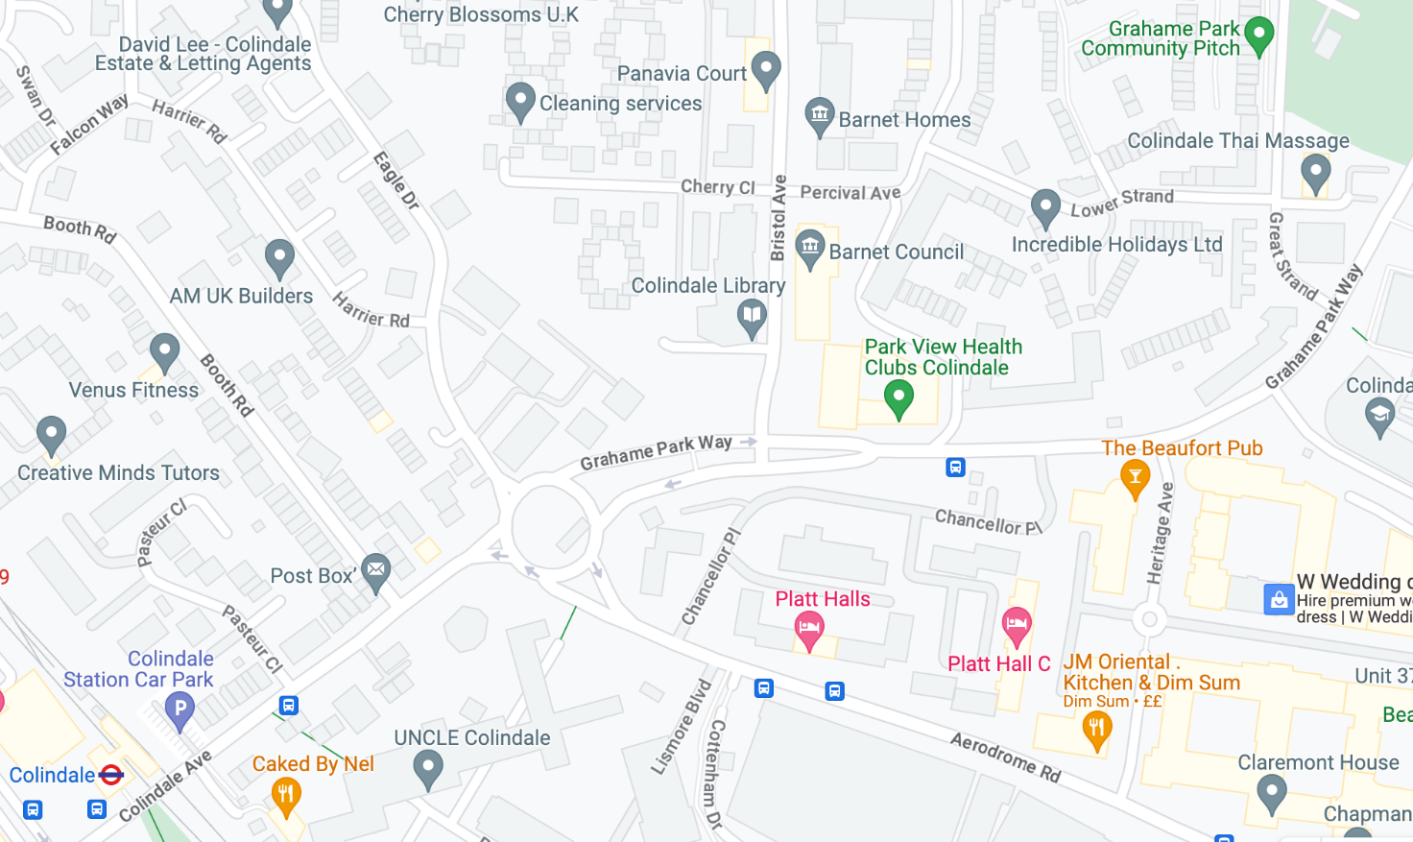

Appendix 2

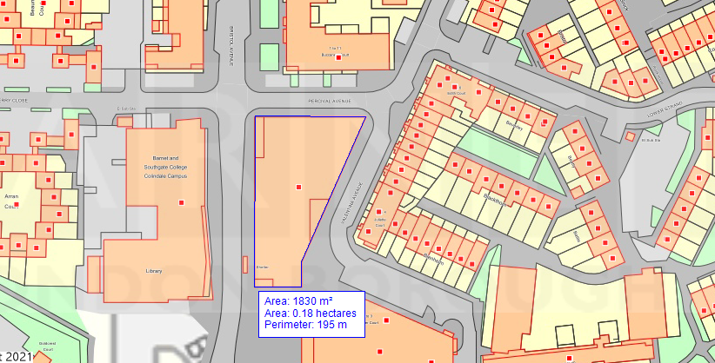

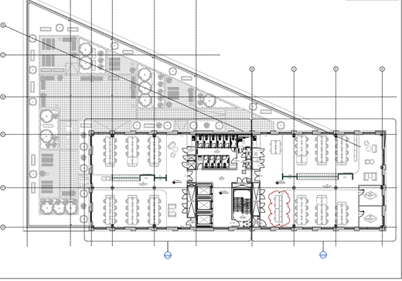
7th Floor Plan

