Equalities and cohesion data summary

A growing borough
The census confirmed Barnet as one of London’s most populous boroughs and shows that growth is spread across the borough, though to varying degrees.
Barnet is becoming an attractive place for young families or Inner Londoners moving further from the city centre as house prices increase. Development is driving large scale population growth and the areas that saw the largest increase in population were Barnet’s regeneration projects (e.g. Beaufort Park in Colindale) or large scale private development (e.g. Burnt Oak).

The number of households and the density of households have increased across the borough. The populations of all wards increased between the censuses. The west of the borough grew the most while pockets of growth occurred in the east, south and north. The largest population increase was in Colindale; the population of which grew by 20.8% (2,947 people). 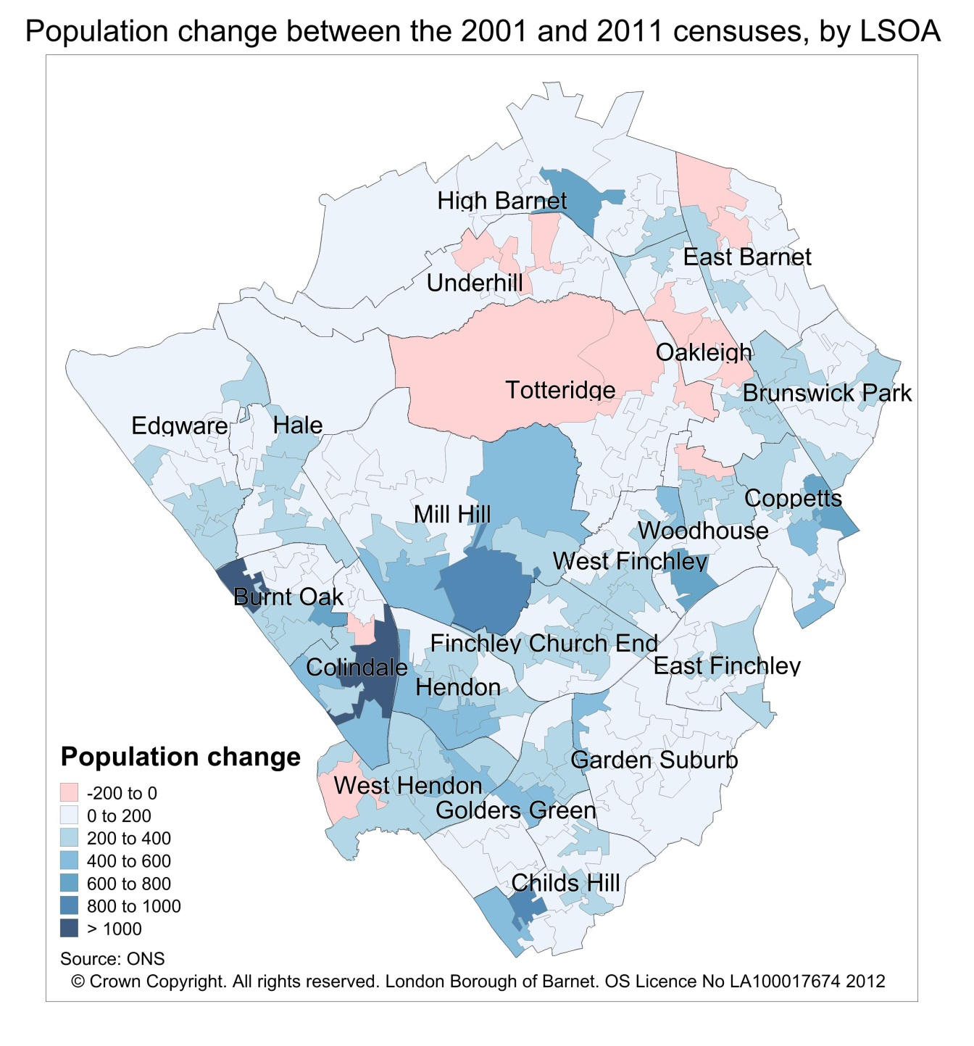
Population growth between the censuses has been driven by an increase in younger populations, particularly in wards in the west of the borough. In eight wards (Coppetts, Colindale, Golders Green, Childs Hill, Finchley Church End, Hendon, West Finchley and Mill Hill) the population of 0 to 19 year olds grew by more than 20% since the last census. The resultant broad trend is that the north of the borough is getting older and the south is getting younger.
A borough that continues to be diverse
Barnet’s ethnic diversity has continued to increase. The population is more diverse in the south of the borough than the north. Barnet has a high percentage of households with multiple ethnicities and multiple languages spoken suggesting a higher level of ethnic integration than other parts of London, particularly other Outer London boroughs.
The borough population as a whole grew by nearly 42,000 people since the last census. Growth in the borough was driven by Asian, Black and mixed ethnicity populations and by people born in other European countries. In the same period the population of White British residents has decreased by more than 26,000.
Those wards with a large ethnic population are the same wards that have large migrant communities. West Hendon and Colindale have less than half of residents born in the UK, while wards in the north of the borough have the highest proportion of UK born residents. The majority of people immigrate to the UK in early adulthood, most likely for education or work purposes and tend to stay in the country long term.

Christianity was once again the most popular religion in Barnet with 41.2% (146,866 people) of the population identifying themselves as Christian. The next most common religions are Judaism (15.2%), Islam (10.3%) and Hinduism (6.2%). Barnet continues to have the largest Jewish population in the country. 16.2% of the population said that they have no religion up from 12.8% in 2001.
Health, wellbeing and lifestyle
The data suggests that the lifestyles of Barnet residents are typical of an Outer London borough. Marital status, occupation and health data all closely match the average Outer London borough profile. 46% of Barnet residents aged 16 and over in Barnet are married and there was a 1% increase in the proportion of lone parents in Barnet.
Self-reported health has improved across all parts of Barnet since 2001. 14% of Barnet residents suffer from a long term health problem or disability that limits their day-to-day activity. Of those people of working age 10% are affected daily by a long term illness or disability.
Barnet has a highly educated population and the occupations of Barnet residents match this profile. More than 40% of the population (aged over 16) are educated to degree level or higher which is above the London average (37.7%). Working residents tend to be in higher management roles in industries such as public service and health and a large proportion are self-employed. These figures support data from other sources that show Barnet having the third highest businesses start-up rate and the third highest business stock in London. 63.5% of Barnet’s working age population were employed at the time of the census, which is higher than the London average and in 2001.
The wards with the highest levels of employment were East Finchley and West Finchley. The lowest rates of employment were in Colindale, Burnt Oak and West Hendon.
A safe and cohesive community
Feeling safe and accepted are important features of a cohesive community. Survey data suggests that the majority of people in Barnet feel safe in their local area, with 81% agreeing they feel safe walking alone in the dark. Barnet has cohesive communities; with 83% of residents agree that people from different backgrounds get on well together in Barnet. 78% of residents also feel that the police in Barnet can be relied on to be there when you need them.
Whilst Barnet has the 12th highest number of anti-social behaviour (ASB) calls in London, taking into account the size of the population Barnet has the 10th lowest rate of ASB calls. 25% of residents worry about ASB in their local area. This data, along with data on hate crime and national trends, especially around feelings to one particular community, provide a key tool to analysing areas where there may be a risk of increased community tension.

