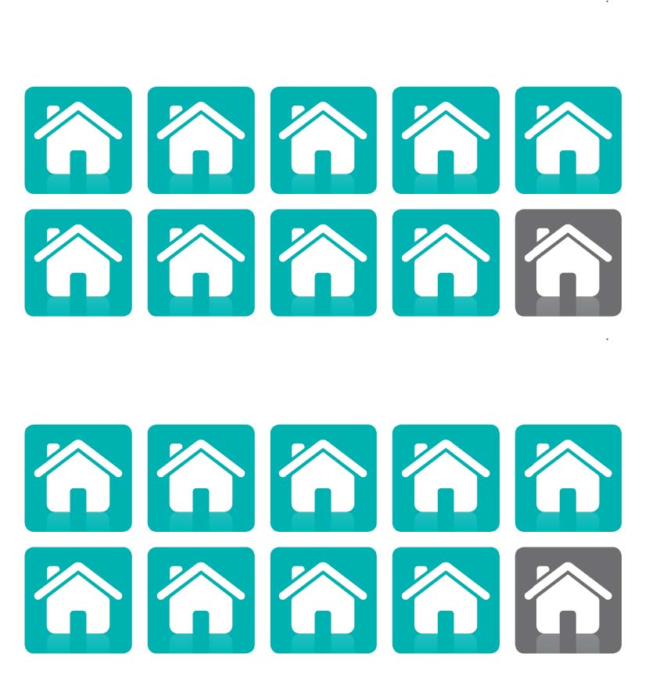

Barnet Council Tax Support Scheme
Effective 1 April 2020
Glossary 3
1 Introduction 5
2 Classes of Persons 5
3 Maximum Council Tax Support for the purposes of calculating eligibility for support under this scheme and amount of reduction 6
4 Non-dependant deductions: pensioners and persons who are not pensioners 6
5 Amount of reduction under this scheme 7
6 Capital 7
7 Extended reductions and qualifying conditions for an extended reduction 7
8 Procedural Matters 7
9 Effective date of a change of circumstance 8
10 Appeals 9
11 Discretionary Reduction see Part 3 of Schedule 1 of the default scheme 9
12 Time and manner of granting relief and recoveries / overpayments 10
Appendix A Protected Groups 10
Appendix B Non-Dependant deductions 10

Glossary

Capital | Money or other assets owned or jointly owned by a person.
Capital Disregard | Windrush Compensation Scheme
Change of Circumstance | Any change of circumstances affecting entitlement to CTS, including but not limited to changes to income, liability, household members or residence that would affect entitlement to CTS.
Council Tax payer | Person liable to pay Council Tax on the property.
Council Tax Support (CTS) | The London Borough of Barnet’s (Barnet) scheme.
Default scheme - Pensioner | The default scheme contained in the Council Tax Reduction Schemes (Default Scheme) (England) Regulations 2012 SI 2886/2012
Banded Scheme - Working Age | Council Tax Support for Working Age customers will be calculated against an income banded scheme and will no longer be in line with the default scheme.
Dispute | Where the CTS recipient disagrees with the amount of CTS awarded or the refusal to award CTS applicant.
Disregards | Deductions allowed against the income.
Earned Income | Has the meaning given with paragraphs 18 and 21 of Schedule 1 of the Prescribed Requirements Regulations.
Excess Income | The amount the taxpayer’s weekly income exceeds their applicable amount for pensioner claims.
Extended Reduction - Pensioner | An amount awarded for a period after the applicant or their partner has started work or increased their hours of work and is therefore no longer entitled to a qualifying benefit or qualifying contributory benefit.
Income - Pensioner | Income from all sources not limited to earnings. Some income will be wholly or partly disregarded.
Income – Working Age | Council Tax Support will be calculated solely on earnings to set the appropriate band.
Local Authority Error | Change following a Local Authority or official error
Maximum liability | The maximum liability is the maximum band after any Council Tax discounts or band reductions awarded under the Local Government Finance Act 1992. For example, single person discounts or band reductions due to disability.
Minimum Income Floor | A self-employed person declaring less income than the national living wage will have their Council Tax Support calculated on a notional income equal to that of the national living wage.
Non-Dependant | Anyone who lives with you who is over 18 and is not your partner, a dependent child, joint tenant or sub-tenant.
Non-Dependant Deduction | An amount deducted from your entitlement depending on the Non-Dependants circumstances.
Overpayment | Any amount of CTS awarded to which the recipient is not entitled.
Pension Age | The age at which a person is eligible to claim State Pension Credit. Please note the age is changing to reflect the equalisation of pension ages between men and woman and the planned increase in retirement age.
Premium | An additional element forming part of the applicable amount relating to the individual or couple’s circumstances. For working age claimants there will be no applicable amounts as an income banded scheme calculates entitlement by categorising income against the correct band.
Prescribed Requirements Regulations | Council Tax Reduction Schemes (Prescribed Requirements) (England) Regulations 2012 SI 2885 2012.
Protected group | Groups listed in Appendix A to which the maximum award does not apply.
Taper | The rate at which CTS is withdrawn if the income including tariff income is greater than the applicable amount or living allowance. Not applicable to working age customers who will have their CTS calculated under a banded income scheme.
Tariff income – Pensioners (Default) | Income generated by savings and capital between the lower and upper capital thresholds.
Work | Employed or self-employed.
Working Age | The age below which a person or couple is eligible to claim State Pension Credit.
1992 Act | Local Government Finance Act 1992.

1 Introduction

The London Borough of Barnet’s (“LBB”) Council Tax Reduction Scheme is based on the default scheme and prescribed requirements regulations for pension age customers, except where the contrary is set out within the scheme. Definitions and detail from the regulations are not replicated in this document and the detail can be found by following the links below.

Council Tax Reduction Schemes (Prescribed Requirements) (England) Regulations 2012 SI 2885/2012 (as amended)
Council Tax Reduction Schemes (Default Scheme) (England) Regulations 2012 SI 2886/2012 (as amended)

The scheme for working age applicants will no longer be based on the default scheme and will calculate the CTS award using an income banded scheme. It has the following features:

- The number of calculations following changes in Universal Credit will be greatly reduced under the banded scheme. Only changes that alter the banding group will be applied. This reduces the regular monthly changes brought about by Universal Credit therefore reducing the possibility of monthly rebilling.

- Only earned income will be used in the calculation within the banded scheme. All other income will be disregarded. I.e. Disability Living Allowance, War Pensions and Child Benefit will continue to be disregarded in the calculation.

- For working age claims, the weekly liability will be reduced by the Non-Dependant deduction.

- A minimum income floor will apply for the self-employed. A self-employed person declaring less income than the national living wage will have their Council Tax Support calculated on a notional income equal to that of the national living wage.

2 Classes of Persons

2.1 Classes of persons excluded from the scheme
Classes of persons to be excluded from the scheme are as set out in the prescribed requirements regulations, including persons treated as not in Great Britain and persons subject to immigration control.
2.2 Classes of person entitled to a reduction under this scheme
Pensioners
Classes A-C Pensioners who fall within any of classes A to C in the prescribed requirements regulations.

Working age persons
Persons who are not pensioners who have no earned income will fall into income band 1 of the table below.

Persons who are not pensioners who have earned income will receive a maximum level of support depending on what earnings threshold they fall into, as per the table below. Earned income will be calculated net of income tax, national insurance and 50% of pension contributions, there will be no other deductions.

Income Band | Discount off CT liability | Earnings threshold (monthly)
1 | 72.00% | No earnings
2 | 52.00% | <£500
3 | 44.00% | £500.01-£800
4 | 36.00% | £800.01-£1100
5 | 28.00% | £1100.01-£1400
6 | 20.00% | £1400.01-£1700
7 | 12.00% | £1700.01-£2000

Persons in receipt of Universal Credit will have their Council Tax Support calculated using the earnings verified on the Universal Credit notice.

Persons not in receipt of Universal Credit will be required to evidence their circumstances, such as earnings.

Persons who do not have any earned income will have all other income disregarded and be placed in Band 1 of the above table and receive a maximum award of 72%.

3 Maximum Council Tax Support for the purposes of calculating eligibility for support under this scheme and amount of reduction

3.1 Maximum Council Tax Support under this scheme: For classes A to C, the maximum council tax reduction is as set out in regulation 29 of the default scheme.

3.2 Maximum Council Tax Support under this scheme: For persons who are not pensioners
the maximum Council Tax Support is calculated as per section 2.2. Non-dependant deductions will be calculated as per section 4.

4 Non-dependant deductions: pensioners and persons who are not pensioners

The non-dependant deductions for pensioners (classes A –C) are as set out in the prescribed requirements regulations.
The non-dependant deductions for working age from 1st April 2019 are as set out in appendix B.

5 Amount of reduction under this scheme

5.1 Amount of reduction under this scheme
Council Tax Support will then be calculated as per section 2.2.

5.2 Where a working age person is not in receipt of earned income, the award is
- the actual liability for the Council Tax.
- less 28%
- less any non-dependant deductions set out in appendix B
5.3 Where a working age person is in receipt of earned income, the award is
- the actual liability for the Council Tax
- less the maximum Council Tax Support, depending on earnings threshold as per the table below
- less any non-dependent deductions set out in appendix B

Income Band | Contribution towards Council Tax Liability | Earnings threshold (monthly)
1 | 28.00% | No earnings
2 | 48.00% | <£500
3 | 56.00% | £500.01-£800
4 | 64.00% | £800.01-£1100
5 | 72.00% | £1100.01-£1400
6 | 80.00% | £1400.01-£1700
7 | 88.00% | £1700.01-£2000

6 Capital

The capital rules for calculating eligibility for a reduction are as set out in the default scheme, save that for working age – where capital exceeds £6,000, there will be no entitlement to Council Tax Support.

Income and capital payments in relation the Windrush Compensation Scheme will be disregarded in line with Housing Benefit regulations.

7 Extended reductions and qualifying conditions for an extended reduction

Extended reductions and qualifying conditions for extended reductions for those of pensionable age will be as set out in the default scheme.

8 Procedural Matters

8.1 Applications
CTS will only be paid upon receipt of an application. Applications must be made in writing and received by LBB’s Revenues and Benefits Service, or received electronically via LBB’s website or in some other format as LBB may decide. If a request for CTS is received by the Revenues and Benefits Service by any means including one that is not in the correct format LBB will invite the applicant to complete an appropriate application. If the applicant does so and it is received within one month of being asked to do so then the application date will be the date the original request was received.
When an application for CTS is made during the same week as the Council Tax liability start date, the CTS award will commence from the liability start date. For applications made outside the first week of liability, the CTS award will commence from the following Monday of the date of application.
If a claim is made for Housing Benefit and the person claiming is also liable for Council Tax at the same dwelling then the Housing Benefit claim will be treated as a claim for Council Tax Support unless within fourteen days of receipt of confirmation of the award from LBB, the customer advises LBB in writing that they do not wish to claim.
For those of working age, where an application is defective or incomplete and the applicant or the person acting for them has not supplied the information requested or properly completed an application form within one month (or such longer period as LBB considers reasonable) of being asked to do so then LBB will decide that the applicant no longer wishes to apply for a reduction.
Where following a change of circumstance the person receiving a reduction is asked to supply evidence or information in support of their claim and fails to do so within one month (or such longer period as LBB considers reasonable) then the CTS award will be amended based upon an adverse inference of the information held from the date the change of circumstances occurred. This could lead to any award being ended.
Where an application is made for Universal Credit, Income Support, Jobseekers Allowance (Income Based) or Income Related Employment and Support Allowance and the Department of Work and Pensions or the CTS applicant makes LBB aware of this fact within 4 weeks of them becoming entitled to one of the above benefits then the date of application will be treated as made on date they become entitled to one of the above benefits.
Applications for CTS can be made up to 13 weeks in advance prior to an event that would entitle them to CTS.

8.1 Backdating an award

For those of Pensionable age the rules for backdating a claim are set out in the default scheme and prescribed requirement regulations.

For those of working age a claim can be backdated for a maximum of 6 months if continuous good cause for failing to apply sooner can be shown. All applications must be in writing.

9 Effective date of a change of circumstance

For those of Pensionable age the effective date of a change of circumstance is as set out in the default scheme.
For those of working age the effective date of a change of circumstances is as set out Regulation 107 of the Default regulations. However, where an applicant is required to notify a change of circumstances and:
- the change has been notified more than one month after the change occurred, or such longer time as LBB considers reasonable; and
- it was reasonably practicable for the change to be notified within this period; and
- the new decision on the reduction is advantageous to the applicant; then
the new decision on a reduction will take effect on the date of notification.

10 Appeals

If you disagree with our decision about your council tax reduction, in some cases you will be able to appeal to the Valuation Tribunal. The Tribunal is independent of LBB.
You can appeal to them regarding LBB’s decision about:
- whether you are entitled to a council tax reduction
- how much of a reduction LBB have awarded you under the local scheme.

The Tribunal cannot hear appeals about what is LBB’s scheme, only about the way the scheme has been applied in your case.
The stages to making an appeal are:
- You must first contact LBB in writing explaining why you believe the decision to be wrong. LBB have 2 months to reply to your contact.

- If LBB do not agree with your reasons for the decision being wrong you can then appeal to the Valuation Tribunal.

- If you decide to appeal, you must contact the Valuation Tribunal within 2 months of LBB’s decision and include a copy of the decision with your appeal form. You can either submit an electronic appeal form, download a form to complete offline, or contact the Valuation Tribunal to have them send you an appeal form.

- If LBB have failed to respond to your contact at point 1 above within 4 months you can refer your matter to the Valuation Tribunal without LBB’s decision.
Further details can be obtained from the Valuation Tribunal at the following link. You will be able to download the appeals form or complete the online form from this link also. Should you wish to contact the Valuation Tribunal their contact details can also be obtained from the link below.
https://www.valuationtribunal.gov.uk/your-appeal-type/council-tax/council-tax-reduction/

11 Discretionary Reduction see Part 3 of Schedule 1 of the default scheme (Discretionary Council Tax Hardship payment)

An application to the authority for a reduction under section 13A(1)(c) of the 1992 Act must be made –

- In writing, or;

- By means of an electronic communication (see part 4 of Schedule 1) or;

- Via LBB’s website.

The applicant must state why the request is being made and supply such evidence and information as the Council may require in support of the request.
If for any reason the request is not in a form that LBB can accept then the applicant will be supplied with a suitable form.

Should an overpayment of CTS arise due to Local Authority or official error, whereby the local authority contributed to the retrospective reduction and deem it unreasonable to suggest the resident would have known they were receiving too much entitlement, residents can apply for a Discretionary Council Tax Hardship payment to offset the overpayment.

Where practicable and the local authority is aware, the authority will make claimants aware of their ability to apply for support.
Applications will be considered based on hardship and remain discretionary.

12 Time and manner of granting relief and recoveries / overpayments

Where the Council Tax payer is entitled to an increase or decrease in their reductions following a reported change of circumstance, LBB will issue a substitute demand notice taking into account the increase or decrease in liability.
LBB will:

- Recover over-entitlement of council tax support – this will be treated as an underpayment of Council Tax and collected via Council Tax enforcement methods;

- Take recovery action according to the circumstances of the applicant;

- Credit the Council Tax account with any underpayment of CTS.

Effective from 1 April 2020

Appendix A Protected Groups
Protected group
Where claimant or partner receives a War Pension, or a War Widow(ers) pension, or a War Disablement Pension or a regular payment under the armed forces compensation scheme.

Appendix B Non-Dependant deductions
Description | Deduction
Gross income greater than or equal to £200.00 per week. | £11.00 per week
Gross income less than or equal to £199.99 per week. | £5.00 per week

