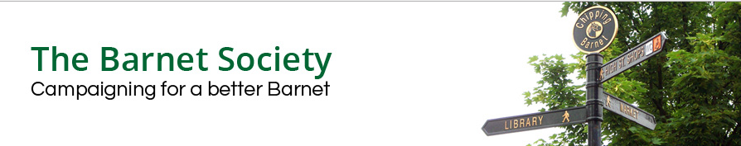

VICTORIA QUARTER – PUBLIC INQUIRY

Summary of statement by Robin Bishop on behalf of the Barnet Society

21 July 2022 (morning of Day 3)

The Barnet Society has previously submitted a representation to the Planning Inspectorate.

In response to the Inspector’s invitation, I would like to take the opportunity to emphasize a couple of key matters.

The first is that in 2010 our Society had been impressed by the Council’s exemplary New Barnet Town Centre Framework, which was based on local consultation and set out a clear direction of travel for development of the neighbourhood including the former gasworks site. We have also been inspired by the New Barnet Community Association’s and Save New Barnet’s creative participation in the subsequent proposal for a mixed housing scheme that was granted planning approval in 2016 (and which we supported).

The second is that, as a former architect and RIBA Client Design Adviser, I recognise that what was acceptable in 2016 might need updating in the light of evolving technical and other thinking. However, the latest scheme is a generic international modernist solution that has nothing in common with New Barnet’s character. It is a design approach that had been discredited when I was an architectural student over half a century ago, and New Barnet deserves better.

