
London Borough of Barnet Pension Fund
Funding Strategy Statement covering the period 1 April 2023 to 31 March 2026

Contents

London Borough of Barnet Pension Fund – Funding Strategy Statement Page
- Introduction 1
- How does the fund calculate employer contributions? 4
- What additional contributions may be payable? 7
- How does the fund calculate assets and liabilities? 8
- What happens when an employer joins the fund? 9
- What happens when an employer leaves the fund? 11
- What are the statutory reporting requirements? 14
Appendices
Appendix A – The regulatory framework Appendix B – Roles and responsibilities Appendix C – Risks and controls Appendix D – Actuarial assumptions

- Introduction

This document sets out the funding strategy statement (FSS) for the London Borough of Barnet Pension Fund. Through the consultation process this document was supplemented by a preface document and addendum (see Appendix E and Appendix F). These documents provide more specific commentary on our Strategy and experience since the last FSS was set as part of the 31 March 2019 valuation, as well as the rationale for introducing a second funding test for certain employers to help stabilise contribution rates. Further information was also provided at Pension Fund Committee meetings held on:

- 7 July 2022
- 10 November 2022
- 31 January 2023
- 22 March 2023

Papers relating to Pension Fund Committee meetings can be accessed here.

Context

The London Borough of Barnet Pension Fund is administered by Barnet Council, known as the administering authority. Barnet council worked with the fund’s actuary, Hymans Robertson, to prepare this FSS which is effective over the period 1 April 2023 to 31 March 2026.

There’s a regulatory requirement for Barnet Council to prepare an FSS. You can find out more about the regulatory framework in Appendix A. If you have any queries about the FSS, contact david.spreckley@barnet.gov.uk.

What is the London Borough of Barnet Pension Fund?

The London Borough of Barnet Pension Fund is part of the Local Government Pension Scheme (LGPS). You can find more information about the LGPS at www.lgpsmember.org. The administering authority runs the fund on behalf of participating employers, their employees and current and future pensioners. You can find out more about roles and responsibilities in Appendix B.

What are the funding strategy objectives?

In addition to the overall aims highlighted in the preface document, the more general funding strategy objectives are to:

    - take a prudent long-term view to secure the regulatory requirement for long-term solvency, with sufficient funds to pay benefits to members and their dependants
    - use a balanced investment strategy to minimise long-term cash contributions from employers and meet the regulatory requirement for long-term cost efficiency
    - where appropriate, ensure stable employer contribution rates
    - reflect different employers’ characteristics to set their contribution rates, using a transparent funding strategy
    - use reasonable measures to reduce the risk of an employer defaulting on its pension obligations.

Who is the FSS for?

The FSS is mainly for employers participating in the fund, because it sets out how money will be collected from them to meet the fund’s obligations to pay members’ benefits.
Different types of employers participate in the fund:

Scheduled bodies

Employers who are specified in a schedule to the LGPS regulations, including councils and employers like academies and further education establishments. Scheduled bodies must give employees access to the LGPS if they can’t accrue benefits in another pension scheme, such as another public service pension scheme.

Barnet Council has a number of wholly owned subsidiary companies who participate in the Fund and these have been treated as Schedule Bodies.

Middlesex University and Barnet & Southgate College are substantial Schedule Bodies within the Fund.

Admission bodies

Other employers can join through an admission agreement. The fund can set participation criteria for them and can refuse entry if the requirements aren’t met. This type of employer includes contractors providing outsourced services like cleaning or catering to a scheduled body.

Some existing employers may be referred to as community admission bodies (CABs). CABs are employers with a community of interest with another scheme employer. Others may be called transferee admission bodies (TABs), that provide services for scheme employers. These terms aren’t defined under current regulations but remain in common use from previous regulations.

How does the funding strategy link to the investment strategy?

The funding strategy sets out how money will be collected from employers to meet the fund’s obligations. Contributions, assets and other income are then invested according to an investment strategy set by the administering authority. You can find the investment strategy at here.

The funding and investment strategies are closely linked. The fund must be able to pay benefits when they are due – those payments are met from a combination of contributions (through the funding strategy) and asset returns and income (through the investment
strategy). If investment returns or income fall short the fund won’t be able to pay benefits, so higher contributions would be required from employers.

Does the funding strategy reflect the investment strategy?

The funding policy is consistent with the investment strategy. Future investment return expectations are set with reference to the investment strategy, including a margin for prudence which is consistent with the regulatory requirement that funds take a ‘prudent longer-term view’ of funding liabilities (see Appendix A).
- How does the fund calculate employer contributions?

Calculating contribution rates

Employee contribution rates are set by the LGPS regulations. Employer contributions are made up of three elements:
    - the primary contribution rate – contributions payable towards future benefits
    - the secondary contribution rate – the difference between the primary rate and the total employer contribution

The primary rate also includes an allowance for the fund’s expenses.

The fund actuary uses a model to project each employer’s asset share over a range of future economic scenarios. The contribution rate takes each employer’s assets into account as well as the projected benefits due to their members. The value of the projected benefits is worked out using employer membership data and the assumptions in Appendix D.

The total contribution rate for each employer is then based on:

    - the funding target – how much money the fund aims to hold for each employer
    - the time horizon – the time over which the employer aims to achieve the funding target
    - the likelihood of success – the proportion of modelled scenarios where the funding target is met.

This approach takes into account the maturing profile of the membership when setting employer contribution rates.

The contribution rate calculation

Table 2: contribution rate calculation for individual or pooled employers
Type of employer |  | Scheduled bodies |  |  | TABs
Sub-type | Local authorities*** | Universities | Colleges | Academies | (all)
Funding target* | Ongoing | Least Risk | Ongoing | Ongoing | Contractor exit basis, assuming fixed-term contract in the fund
Minimum likelihood of success** | 70% | 50% | 70% | 70% | 70%
Maximum time horizon** | 17 years | 15 years | 15 years | 15 years | Same as the letting employer
Secondary rate | % of payroll | Monetary amount | Monetary amount | % of payroll | % of payroll
Phasing of contribution changes | None | None | None | 3-years | None

*See Appendix D for further information on funding targets.

**Where funding approach indicated a contribution rate would reduce a second test was applied to certain employers. The second test applied an 80% minimum likelihood of success over a 15-year period. Note that this test was not applied for Middlesex University, Barnet & Southgate College and Contractors. Further details on this approach and the rationale for adopting it is set out under Appendix F.

***The Total Contribution for the Council using the parameters set out above was 27.4% of Pensionable Pay. After considering the output for the Council from applying Test 2 it was agreed to increase this rate to 28.4% of pay (from 28.9% paid prior to 1 April 2023).

Reviewing contributions between valuations

The fund may amend contribution rates between formal valuations, in line with its policy on contribution reviews. The fund’s policy can be found here. The purpose of any review is to establish the most appropriate contributions. A review may lead to an increase or decrease in contributions.

What is pooling?
The administering authority does not operate funding pools for similar types of employers, apart from LEA Schools which are pooled with the Council. This means that each employer of the Fund receives a specific contribution rate reflecting their underlying membership and asset share.

Note that Academies contribution rates were pooled at the 2019 valuation. However, this pooling was purely for administrative purpose and there was no actual cross subsidy of contributions or experience across different Academies. This meant that some Academies may have been substantially over or under paying contributions relative to their share of obligations.

For the 2022 valuation each Academies contribution will be assessed based on their actual share of obligations. Academies are subject to the two-test approach we have adopted for this valuation. Where an Academy’s contribution rates has increased, we may, with the advice of the Actuary, spread any increase over a three-year period.

Administering authority discretion

Individual employers may be affected by circumstances not easily managed within the FSS rules and policies. If this happens, the administering authority may adopt alternative funding approaches on a case-by-case basis.

Additionally, the administering authority may allow greater flexibility to the employer’s contributions if added security is provided.

Flexibility could include things like a reduced contribution rate, extended time horizon, or permission to join a pool. Added security may include a suitable bond, a legally binding guarantee from an appropriate third party, asset backed funding, security over an asset or a negative pledge.

- What additional contributions may be payable?

Pension costs – awarding additional pension and early retirement on non ill- health grounds

An employer may decide to award an additional pension to an employee if this is allowed in their discretions policy. If an employer awards an additional pension, the employer must pay an additional contribution to the fund as a single lump sum. The amount is set by guidance issued by the Government Actuary’s Department and updated from time to time.

Under its discretions policy, an employer may also decide to waive actuarial reductions when an employee retires before their normal retirement age. This may mean that there is an additional cost to the employer, who will be asked to pay this additional contribution, which is called a “strain payment”.

This is payable when the employee retires, and employers must also make strain payments as a single lump sum immediately.

Pension costs – early retirement on ill-health grounds

If a member retires early because of ill-health, there will be a funding strain cost to the employer, which may be a large sum.

The administering authority does not offer any arrangement to mitigate this. Individual employers should make their own arrangements if they are concerned about the risk of unmanageable ill-health strain costs.

The ill health funding strain cost is not paid at the time of retirement. It is included in the actuarial calculation of the employers’ contribution rate at the triennial valuation following the employee’s retirement.
- How does the fund calculate assets and liabilities?

How are employer asset shares calculated?

The fund adopts a cashflow approach to track individual employer assets. Each employer’s assets are calculated triennially by considering cashflows paid in/out and investment returns to give a new asset value.

If an employee moves one from one employer to another within the fund, assets equal to the cash equivalent transfer value (CETV) will move from the original employer to the receiving employer’s asset share. Alternatively, if employees move when a new academy is formed or an outsourced contract begins, the fund actuary will calculate assets linked to the value of the liabilities transferring (see section 5.2).

How are employer liabilities calculated?

The fund holds membership data for all active, deferred and pensioner members. Based on this data and the assumptions in Appendix D, the fund actuary projects the expected benefits for all members into the future. This is expressed as a single value – the liabilities – by allowing for expected future investment returns.

Each employer’s liabilities reflect the experience of their own employees and ex-employees.

Benefits are valued in line with the regulations in force at the time of the valuation, with an exception relating to the McCloud ruling. The benefits of members likely to be affected by the McCloud ruling have instead been valued in line with the expected regulations, reflecting an underpin as directed by DLUHC.

What is a funding level?

An employer’s funding level is the ratio of the market value of asset share against liabilities. If this is less than 100%, the employer has a shortfall: the employer’s deficit. If it is more than 100%, the employer is in surplus. The amount of deficit or surplus is the difference between the asset value and the liabilities value.

Funding levels and deficit/surplus values measure a particular point in time, based on a particular set of future assumptions. While this measure is of interest, for most employers the main issue is the level of contributions payable. The funding level does not directly drive contribution rates. See section 2 for further information on rates.
- What happens when an employer joins the fund?

When can an employer join the fund

Employers can join the fund if they are a new scheduled body or a new admission body. New designated employers may also join the fund if they pass a designation to do so.
On joining, the fund will determine the assets and liabilities for that employer within the Fund. The calculation will depend on the type of employer and the circumstances of joining.
A contribution rate will also be set. This will be set in accordance with the calculation set out in Section 2, unless alternative arrangements apply (for example, the employer has agreed a pass-through arrangement). More details on this are in Section 5.4 below.

New academies

New academies (including free schools) join the fund as separate scheduled employers. Only active members of former council schools transfer to new academies. Free schools do not transfer active members from a converting school but must allow new active members to transfer in any eligible service.

Liabilities for transferring active members will be calculated (on the ongoing basis) by the fund actuary on the day before conversion to an academy. Liabilities relating to the converting school’s former employees (i.e. members with deferred or pensioner status) remain with the ceding council.

New academies will be allocated an asset share based on the estimated funding level of the ceding council’s active members, having first allocated the council’s assets to fully fund their deferred and pensioner members. This funding level will then be applied to the transferring liabilities to calculate the academy’s initial asset share, capped at a maximum of 100%.

The council’s estimated funding level will be based on market conditions on the day before conversion. The fund treats new academies as separate employers in their own right, who are responsible for their allocated assets and liabilities. They won’t be pooled with other employers unless the academy is part of a multi-academy trust (MAT) and the MAT requests that contributions are pooled. The new academies’ contribution rate is based on the current funding strategy (set out in section 2) and the transferring membership.

If an academy leaves one MAT and joins another, all active, deferred and pensioner members transfer to the new MAT.

The fund’s policies on academies may change based on updates to guidance from the Department for Levelling Up, Housing and Communities or the Department for Education. Any changes will be communicated and reflected in future funding strategy statements.

New admission bodies as a results of outsourcing services

New admission bodies usually join the fund because an existing employer (usually a scheduled body like a council or academy) outsources a service to another organisation (a contractor). This involves TUPE transfers of staff from the letting employer to the contractor. The contractor becomes a new participating fund employer for the duration of the contract
and transferring employees remain eligible for LGPS membership. At the end of the contract, employees typically revert to the letting employer or a replacement contractor.

Liabilities for transferring active members will be calculated by the fund actuary on the day before the outsourcing occurs.

New contractors will be allocated an asset share equal to the value of the transferring liabilities. The admission agreement may set a different initial asset allocation, depending on contract-specific circumstances.

There is flexibility for outsourcing employers when it comes to pension risk potentially taken on by the contractor. You can find more details on outsourcing options from the administering authority or in the contract admission agreement.

Other new employers

There may be other circumstances that lead to a new admission body entering the fund, e.g. set up of a wholly owned subsidiary company by a Local Authority. Calculation of assets and liabilities on joining and a contribution rate will be carried out allowing for the circumstances of the new employer.

New designated employers may also join the fund. These are usually town and parish councils. Contribution rates will be set using the same approach as other designated employers in the fund.

Risk assessment for new admission bodies

Under the LGPS regulations, a new admission body must assess the risks it poses to the fund if the admission agreement ends early, for example if the admission body becomes insolvent or goes out of business. In practice, the fund actuary assesses this because the assessment must be carried out to the administering authority’s satisfaction.
After considering the assessment, the administering authority may decide the admission body must provide security, such as a guarantee from the letting employer, an indemnity or a bond.

This must cover some or all of the:
    - strain costs of any early retirements, if employees are made redundant when a contract ends prematurely
    - allowance for the risk of assets performing less well than expected
    - allowance for the risk of liabilities being greater than expected
    - allowance for the possible non-payment of employer and member contributions
    - admission body’s existing deficit.
- What happens when an employer leaves the fund?

What is a cessation event?

Triggers for considering cessation from the fund are:

    - the last active member stops participation in the fund. The administering authority, at their discretion, can defer acting for up to three years by issuing a suspension notice. That means cessation won’t be triggered if the employer takes on one or more active members during the agreed time
    - insolvency, winding up or liquidation of the admission body
    - a breach of the agreement obligations that isn’t remedied to the fund’s satisfaction
    - failure to pay any sums due within the period required
    - failure to renew or adjust the level of a bond or indemnity, or to confirm an appropriate alternative guarantor
    - termination of a deferred debt arrangement (DDA).

If no DDA exists, the administering authority will instruct the fund actuary to carry out a cessation valuation to calculate if there is a surplus or a deficit when the fund leaves the scheme.

What happens on cessation?

The administering authority must protect the interests of the remaining fund employers when an employer leaves the scheme. The actuary aims to protect remaining employers from the risk of future loss. The funding target adopted for the cessation calculation is below. These are defined in Appendix D.

- Where there is no guarantor, cessation liabilities and a final surplus/deficit will usually be calculated using a low-risk basis, which is more prudent than the ongoing participation basis. The low-risk exit basis is defined in Appendix D.
- Where there is a guarantor, the guarantee will be considered before the cessation valuation. Where the guarantor is a guarantor of last resort, this will have no effect on the cessation valuation. If this isn’t the case, cessation may be calculated using the same basis that was used to calculate liabilities (and the corresponding asset share) on joining the fund.
- Depending on the guarantee, it may be possible to transfer the employer’s liabilities and assets to the guarantor without crystallising deficits or surplus. This may happen if an employer can’t pay the contributions due and the approach is within guarantee terms.

If the fund can’t recover the required payment in full, unpaid amounts will be paid by the related letting authority (in the case of a ceased admission body) or shared between the other fund employers. This may require an immediate revision to the rates and adjustments certificate or be reflected in the contribution rates set at the next formal valuation.
The fund actuary charges a fee for cessation valuations and there may be other cessation expenses. Fees and expenses are at the employer’s expense and are deducted from the cessation surplus or added to the cessation deficit. This improves efficiency by reducing transactions between employer and fund.

The cessation policy can be found here.

What happens if there is a surplus?

If the cessation valuation shows the exiting employer has more assets than liabilities – an exit credit – the administering authority can decide how much will be paid back to the employer based on:

    - the surplus amount
    - the proportion of the surplus due to the employer’s contributions
    - any representations (like risk sharing agreements or guarantees) made by the exiting employer and any employer providing a guarantee or some other form of employer assistance/support
    - any other relevant factors.

The exit credit policy can be found here.

How do employers repay cessation debts?

If there is a deficit, full payment will usually be expected in a single lump sum or:

    - spread over an agreed period, if the employer enters into a deferred spreading agreement
    - if an exiting employer enters into a deferred debt agreement, it stays in the fund and pays contributions until the cessation debt is repaid. Payments are reassessed at each formal valuation.

The employer flexibility can be found here.

What if an employer has no active members?

When employers leave the fund because their last active member has left, they may pay a cessation debt, receive an exit credit or enter a DDA/DSA.

Are bulk transfers allowed?

Cases will be looked at individually, but generally:

    - the fund won’t pay bulk transfers greater in value than either the asset share of the transferring employer in the fund, or the value of the liabilities of the transferring members, whichever is lower
    - the fund won’t grant added benefits to members bringing in entitlements from another fund, unless the asset transfer is enough to meet the added liabilities
    - the fund may permit shortfalls on bulk transfers if the employer has a suitable covenant and commits to meeting the shortfall in an appropriate period, which may require increased contributions between valuations.

- What are the statutory reporting requirements?

Reporting regulations

The Public Service Pensions Act 2013 requires the Government Actuary’s Department to report on LGPS funds in England and Wales after every three-year valuation, in what’s usually called a section 13 report. The report should include confirmation that employer contributions are set at the right level to ensure the fund’s solvency and long-term cost efficiency.

Solvency

Employer contributions are set at an appropriate solvency level if the rate of contribution targets a funding level of 100% over an appropriate time, using appropriate assumptions compared to other funds. Either:

- employers collectively can increase their contributions, or the fund can realise contingencies to target a 100% funding level
or
- there is an appropriate plan in place if there is, or is expected to be, a reduction in employers’ ability to increase contributions as needed.

Long-term cost efficiency

Employer contributions are set at an appropriate long-term cost efficiency level if the contribution rate makes provision for the cost of current benefit accrual, with an appropriate adjustment for any surplus or deficit.

To assess this, the administering authority may consider absolute and relative factors. Relative factors include:

- comparing LGPS funds with each other
- the implied deficit recovery period
- the investment return required to achieve full funding after 20 years.

Absolute factors include:

- comparing funds with an objective benchmark
- the extent to which contributions will cover the cost of current benefit accrual and interest on any deficit
- how the required investment return under relative considerations compares to the estimated future return targeted by the investment strategy
- the extent to which contributions paid are in line with expected contributions, based on the rates and adjustment certificate
- how any new deficit recovery plan reconciles with, and can be a continuation of, any previous deficit recovery plan, allowing for fund experience.

These metrics may be assessed by GAD on a standardised market-related basis where the fund’s actuarial bases don’t offer straightforward comparisons.

- establish a clear and transparent fund-specific strategy identifying how employers’ pension liabilities are best met going forward
- support the regulatory framework to maintain as nearly constant employer contribution rates as possible
- ensure the fund meets its solvency and long-term cost efficiency objectives
- take a prudent longer-term view of funding those liabilities.

To prepare this FSS, the administering authority has used guidance by the Chartered Institute of Public Finance and Accountancy (CIPFA).

A2 Consultation

Both the LGPS regulations and most recent CIPFA guidance state the FSS should be prepared in consultation with “persons the authority considers appropriate”. This should include ‘meaningful dialogue… with council tax raising authorities and representatives of other participating employers’.

For the 31 March 2022 we ran a two-month consultation period running from 1 November 2022 to 31 December 2022. Each employer will be provided with a copy of this document (in draft form) and the opportunity to speak to the Head of Pensions and Treasury and the Scheme Actuary as required.

The Council also hosted an employer forum, which was attended by the Scheme Actuary and Officers to explain the document. During the consultation period employers received their individual results.

A3 How is the FSS published?

The FSS will be published here.

A4 How often is the FSS reviewed?

The FSS is reviewed in detail at least every three years as part of the valuation. Amendments may be made before then if there are regulatory or operational changes. Any amendments will be consulted on, agreed by the Pensions Committee and included in the Committee meeting minutes.

A5 How does the FSS fit into the overall fund documentation?

Appendix B – Roles and responsibilities

B1 The administering authority:
- operates the fund and follows all Local Government Pension Scheme (LGPS) regulations
- manages any conflicts of interest from its dual role as administering authority and a fund employer
- collects employer and employee contributions, investment income and other amounts due
- ensures cash is available to meet benefit payments when due
- pays all benefits and entitlements
- invests surplus money like contributions and income which isn’t needed to pay immediate benefits, in line with regulation and the investment strategy
- communicates with employers so they understand their obligations
- safeguards the fund against employer default
- works with the fund actuary to manage the valuation process
- provides information to the Government Actuary’s Department so they can carry out their statutory obligations
- consults on, prepares and maintains the funding and investment strategy statements
- tells the actuary about changes which could affect funding
- monitors the fund’s performance and funding, amending the strategy statements as necessary
- enables the local pension board to review the valuation process.

B2 Individual employers:
- deduct the correct contributions from employees’ pay
- pay all contributions by the due date
- have appropriate policies in place to work within the regulatory framework
- make additional contributions as agreed, for example to augment scheme benefits or early retirement strain
- tell the administering authority promptly about any changes to circumstances, prospects or membership which could affect future funding.
- make any required exit payments when leaving the fund.

B3 The fund actuary:
- prepares valuations, including setting employers’ contribution rates, agreeing assumptions, working within FSS and LGPS regulations and appropriately targeting fund solvency and long-term cost efficiency
- provides information to the Government Actuary Department so they can carry out their statutory obligations
- advises on fund employers, including giving advice about and monitoring bonds or other security
- prepares advice and calculations around bulk transfers and individual benefits
- assists the administering authority to consider changes to employer contributions between formal valuations
- advises on terminating employers’ participation in the fund
- fully reflects actuarial professional guidance and requirements in all advice.

B4 Other parties:
- internal and external investment advisers ensure the investment strategy statement (ISS) is consistent with the funding strategy statement
- investment managers, custodians and bankers play their part in the effective investment and dis-investment of fund assets in line with the ISS
- auditors comply with standards, ensure fund compliance with requirements, monitor and advise on fraud detection, and sign-off annual reports and financial statements
- governance advisers may be asked to advise the administering authority on processes and working methods
- internal and external legal advisers ensure the fund complies with all regulations and broader local government requirements, including the administering authority’s own procedures
- the Department for Levelling Up, Housing and Communities, assisted by the Government Actuary’s Department and the Scheme Advisory Board, work with LGPS funds to meet Section 13 requirements.

Appendix C – Risks and controls

C1 Managing risks

Some of the key risks facing the Fund together with controls employed to manage those risks are summarised in the tables below

C2 Financial risks

Risk | Control
Fund assets don’t deliver the anticipated returns that underpin the valuation of liabilities and contribution rates over the long-term. | Anticipate long-term returns on a prudent basis to reduce risk of under-performing.  Use specialist advice to invest and diversify assets across asset classes, geographies, managers, etc.  Analyse progress at three-year valuations for all employers.  Roll forward whole fund liabilities between valuations.
Inappropriate long-term investment strategy. | Consider overall investment strategy options as part of the funding strategy. Use asset liability modelling to measure outcomes and choose the option that provides the best balance.  Operate various strategies to meet the needs of a diverse employer group.
Active investment manager under- performs relative to benchmark. | Use quarterly investment monitoring to analyse market performance and active managers, relative to index benchmark.
Pay and price inflation is significantly more than anticipated. | Focus valuation on real returns on assets, net of price and pay increases.  Use inter-valuation monitoring to give early warning.  Employers to be mindful of the geared effect on pension liabilities of any bias in pensionable pay rises towards longer-serving employees.

Risk | Control
Increased employer’s contribution rate affects service delivery and admission/scheduled bodies. | Agree an explicit stabilisation mechanism, with other measures to limit sudden increases in contributions.
Orphaned employers create added fund costs. | Seek a cessation debt (or security/guarantor). Spread added costs among employers.

C3 Demographic risks

Risk | Control
Pensioners live longer, increasing fund costs. | Set mortality assumptions with allowances for future increases in life expectancy.  Use the fund actuary’s experience and access to over 50 LGPS funds to identify changes in life expectancy that might affect the longevity assumptions early.
As the fund matures, the proportion of actively contributing employees declines relative to retired employees. | Monitor at each valuation, consider seeking monetary amounts rather than % of pay.  Consider alternative investment strategies.
Deteriorating patterns of early retirements | Charge employers the extra cost of non ill- health retirements following each individual decision.  Monitor employer ill-health retirement experience, with optional insurance.
Reductions in payroll cause insufficient deficit recovery payments. | Review contributions between valuations. This may require a move in deficit contributions from a percentage of payroll to fixed monetary amounts.

C4 Regulatory risks

Risk | Control
Changes to national pension requirements or HMRC rules. | Consider all Government consultation papers and comment where appropriate.  Monitor progress on the McCloud court case and consider an interim valuation or other action once more information is known.  Build preferred solutions into valuations as required.
Time, cost or reputational risks associated with any DLUHC intervention triggered by the Section 13 analysis (see Section 5). | Take advice from the actuary and consider the proposed valuation approach, relative to anticipated Section 13 analysis.
Changes to employer participation in LGPS funds leads to impacts on funding or investment strategies. | Consider all Government consultation papers and comment where appropriate.  Take advice from the fund actuary and amend strategy.

C5 Governance risks

Risk | Control
The administering authority is not aware of employer membership changes, for example a large fall in employee members, large number of retirements, or is not advised that an employer is closed to new entrants. | The administering authority develops a close relationship with employing bodies and communicates required standards.  The actuary may revise the rates and adjustments certificate to increase an employer’s contributions between valuations  Deficit contributions may be expressed as monetary amounts.
Actuarial or investment advice is not sought, heeded, or proves to be insufficient in some way | The administering authority maintains close contact with its advisers.  Advice is delivered through formal meetings and recorded appropriately.  Actuarial advice is subject to professional requirements like peer review.
The administering authority fails to commission the actuary to carry out a termination valuation for an admission body leaving the fund. | The administering authority requires employers with Best Value contractors to inform it of changes.  CABs’ memberships are monitored and steps are taken if active membership decreases.

Risk | Control
An employer ceases to exist with insufficient funding or bonds. | It’s normally too late to manage this risk if left to the time of departure. This risk is mitigated by:  Seeking a funding guarantee from another scheme employer, or external body.  Alerting the prospective employer to its obligations and encouraging it to take independent actuarial advice.  Vetting prospective employers before admission.  Requiring a bond to protect the fund, where permitted.  Requiring a guarantor for new CABs.  Regularly reviewing bond or guarantor arrangements.  Reviewing contributions well ahead of cessation.
An employer ceases to exist, so an exit credit is payable. | The administering authority regularly monitors admission bodies coming up to cessation.  The administering authority invests in liquid assets so that exit credits can be paid.

C6 Employer covenant assessment and monitoring

Many of the employers participating in the fund, such as TABs and CABs, have no local tax- raising powers. The fund assesses and monitors the long-term financial health of these employers to assess an appropriate level of risk for each employer’s funding strategy.

Type of employer | Assessment | Monitoring
Local Authorities | Tax-raising or government- backed, no individual assessment required | n/a
Colleges & Universities | No formal assessment currently undertaken. However, this is likely to be reviewed over period to 31 March 2025 | n/a
Academies | Government-backed, covered by DfE guarantee in event of MAT failure | Check that DfE guarantee continues, after regular scheduled DfE review
Admission bodies (TABs & CABs) | Bonds or Council guarantee required as a condition of participating in the Fund | Bonds are monitored at PFC meetings

C7 Climate risk and TCFD reporting

The Fund has carried out climate scenario stress testing as part of their funding strategy considerations at the 2022 valuation. The modelling results under the stress tests were slightly worse than the core results but were still within risk tolerance levels, particularly given the severity of the stresses applied.

The Fund is reviewing its Responsible Investment policy and its reporting requirements and is at the very early stages of establishing its framework around how the Fund quantify and manages climate related risks. However, the results from this initial modelling provide some comfort that the modelling approach does not significantly underestimate the potential impact of climate change and that the funding strategy is resilient to climate risks.

We will evolve and update our modelling approach as appropriate once practice in this area becomes more established and our risk management framework becomes more developed.

The results of these stress tests may be used in future to assist with disclosures prepared in line with Task Force on Climate-Related Financial Disclosures (TCFD) principles.

Appendix D – Actuarial assumptions

The fund’s actuary uses a set of assumptions to determine the strategy, and so assumptions are a fundamental part of the funding strategy statement.

D1 What are assumptions?

Assumptions are used to estimate the benefits due to be paid to members. Financial assumptions determine the amount of benefit to be paid to each member, and the expected investment return on the assets held to meet those benefits. Demographic assumptions are used to work out when benefit payments are made and for how long.

The funding target is the money the fund aims to hold to meet the benefits earned to date. Any change in the assumptions will affect the funding target and contribution rate, but different assumptions don’t affect the actual benefits the fund will pay in future.

D2 What assumptions are used to set the contribution rate?

The fund doesn’t rely on a single set of assumptions when setting contribution rates, instead using Hymans Robertson’s Economic Scenario Service (ESS) to project each employer’s assets, benefits and cashflows to the end of the funding time horizon.

ESS projects future benefit payments, contributions and investment returns under 5,000 possible economic scenarios, using variables for future inflation and investment returns for each asset class, rather than a single fixed value.

For any projection, the fund actuary can assess if the funding target is satisfied at the end of the time horizon.

Table: Summary of assumptions underlying the ESS, 31 March 2022

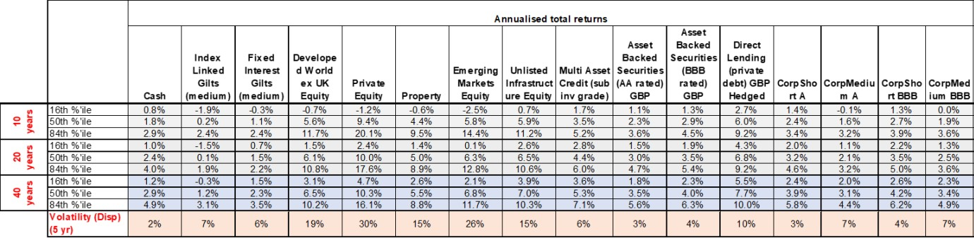
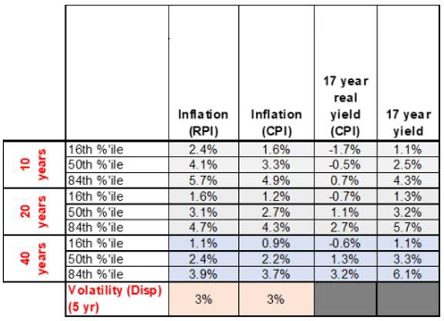

D3 What financial assumptions were used? Future investment returns and discount rate
The fund uses a risk-based approach to generate assumptions about future investment returns over the funding time horizon, based on the investment strategy.

The discount rate is the annual rate of future investment return assumed to be earned on assets after the end of the funding time horizon. The discount rate assumption is set as a margin above the risk-free rate.

Assumptions for future investment returns depend on the funding objective.

 | Employer type | Margin above risk-free rate
Ongoing basis | All employers except transferee admission bodies and closed community admission bodies | 2.0%

Discount rate (for funding level calculation only)

For the purpose of calculating a funding level at the 2022 valuation, a discount rate of 4.6% applies. This is based on a prudent estimate of investment returns, specifically, that there is an 75% likelihood that the fund’s assets will future investment returns of 4.6% over the 20 years following the 2022 valuation date.

Pension increases and CARE revaluation

Deferment and payment increases to pensions and revaluation of CARE benefits are in line with the Consumer Price Index (CPI) and determined by the regulations.

The CPI assumption is based on Hymans Robertson’s ESS model. The median value of CPI inflation from the ESS was 2.7% pa on 31 March 2022.

Salary growth

The salary increase assumption at the latest valuation has been set to 1.0% above CPI pa plus a promotional salary scale.

D4 What demographic assumptions were used?

Demographic assumptions are best estimates of future experience. The fund uses advice from Club Vita to set demographic assumptions, as well as analysis and judgement based on the
fund’s experience.

Demographic assumptions vary by type of member, so each employer’s own membership profile is reflected in their results.

Life expectancy

The longevity assumptions are a bespoke set of VitaCurves produced by detailed analysis and tailored to fit the fund’s membership profile.

Allowance has been made for future improvements to mortality, in line with the 2021 version of the continuous mortality investigation (CMI) published by the actuarial profession. The starting point has been adjusted by +0.25% to reflect the difference between the population-wide data used in the CMI and LGPS membership. A long-term rate of mortality improvements of 1.5% pa applies.

The smoothing parameter used in the CMI model is 7.0. There is little evidence currently available on the long-term effect of Covid-19 on life expectancies. To avoid an undue impact from recently mortality experience on long-term assumptions, no weighting has been placed on data from 2020 and 2021 in the CMI.

Other demographic
assumptions
Retirement in normal health | Members are assumed to retire at the earliest age possible with no pension reduction.
Promotional salary increases | Sample increases below
Death in service | Sample rates below
Withdrawals | Sample rates below
Retirement in ill health | Sample rates below
Family details | A varying proportion of members are assumed to have a dependant partner at retirement or on earlier death. For example, at age 60 this is assumed to be 90% for males and 85% for females. Males are assumed to be 3 years older than females, and partner dependants are assumed to be opposite sex to members.
Commutation | 50% of maximum tax-free cash
50:50 option | 1.0% of members will choose the 50:50 option.

Rates for demographic assumptions

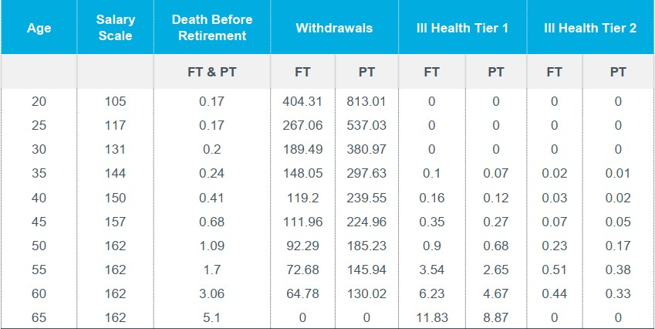

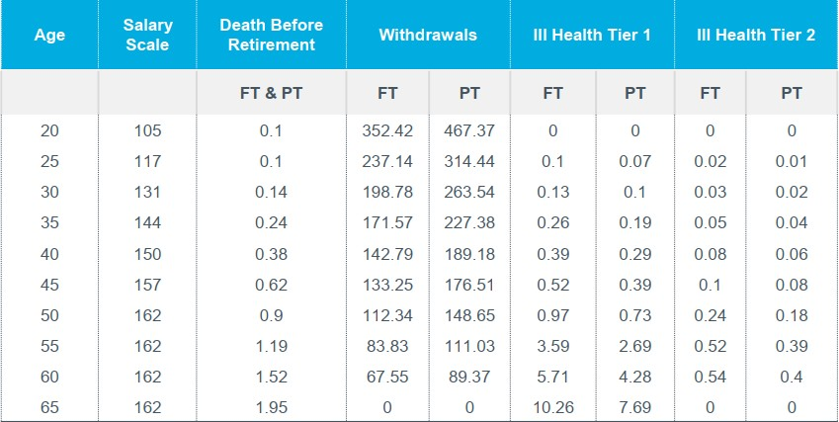

D5 What assumptions apply in a cessation valuation following an employer’s exit from the fund?

Low-risk exit basis

Where there is no guarantor, the low-risk exit basis will apply.

The financial and demographic assumptions underlying the low-risk exit basis are explained below:

- The discount rate is set equal to the annualised yield on long dated government bonds at the cessation date, with a 0% margin. This was 1.7% pa on 31 March 2022.

- The CPI assumption is based on Hymans Robertson’s ESS model. The median value of CPI inflation from the ESS was 2.7% pa on 31 March 2022.

- Life expectancy assumptions are those used to set contribution rates, with one adjustment. A higher long-term rate of mortality improvements of 1.75% pa is assumed.

Contractor exit basis

Where there is a guarantor (e.g. in the case of contractors where the local authority guarantees the contractor’s admission in the fund), the contractor exit basis will apply.

The financial and demographic assumptions underlying the contractor exit basis are equal to those set for calculating contributions rates. Specifically, the discount rate is set equal to the risk-free rate at the cessation date, plus a margin equal to that set to allocate assets to the employer on joining the fund.

Appendix E – Preface Document (this document supplemented our initial FSS consultation)

London Borough of Barnet Pension Fund
Funding Strategy Statement covering the period 1 April 2023 to 31 March 2026

This preface to our Funding Strategy Statement covering the period 1 April 2023 to 31 March 2026 sets out the specifics of the London Borough of Barnet Pension Fund and the key areas we have considered to inform our Funding Strategy. The preface is supported by a more detailed document prepared in collaboration with our advisors, which also includes links to important Fund policies.

E1. What is our overall objective?

  - Our overall objective is to ensure there are sufficient resources to meet pension benefits as they fall due.

  - Our resources are:
    - the assets we hold within the Pension Fund
    - the return we may get on those assets in the future; and
    - the ability for us to ask for contributions from our employer base in the future

  - A secondary condition is that we take risk in a measured way to ensure the overall efficiency and cost effectiveness of funding. Because we are taking risk, we need to manage those risks.

E2. How are we doing against our objectives?

  - At 31 March 2022, and at a “Whole of Fund” level, we had c£1.5bn of assets. The nominal (i.e. not discounted) value of the benefit payments promised to that date, based on Hyman’s central view on long-term inflation, was c£4bn. This leaves c£2.5bn to be funded via investment returns or additional contributions.

  - The balance between how benefits earned to date are expected to be met through current assets and investment returns on those assets is illustrated below – as can be seen, the majority of benefits are expected to be met through investment returns (orange area), which is why focusing on investment returns is so important.

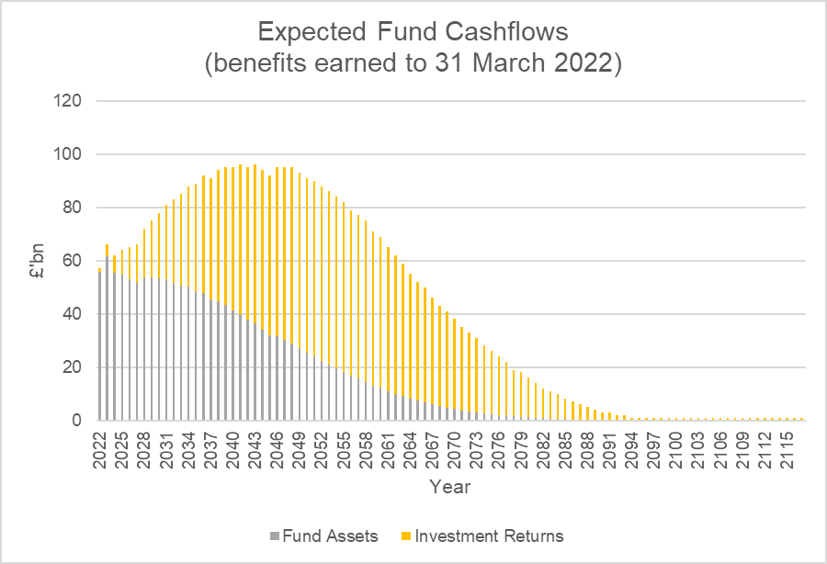

  - Our actuary has calculated that we would need to achieve an annual return of at least 4.7% to meet these payments without requiring further contributions from our employers. Our actuaries assess that the probability of achieving this level of return over the long-term is around 70%.

  - This implies that, whilst there is a positive likelihood that further money isn’t required to fund benefits built up, there is a material probability that the current assets are not sufficient to cover the benefits already promised and that further contributions may be required. This indicates the level of risk being taken to fund our pension obligations.

  - After considering the provisional results of the 31 March 2022 valuation and experience over the inter-valuation period, we are currently comfortable with our funding progress and the level of overall risk we are taking at a “Whole of Fund” level. However, the position for employer groups is more nuanced.

  - An important consideration when thinking about our employer groups and overall risk appetite is the ability to request contributions in the future.

E3. Ability to request further contributions in the future

  - The ability for us to request contributions from employers in the future is a very important part of our overall risk management framework and funding strategy. This ability is constrained by the following two factors:

    - The ability of the employer to flex its operating costs to allocate more resources towards the pension scheme if required - For the majority of our employers this is limited without due notice (possibly a number of years). We also do not wish to negatively impact public service delivery because of increasing pension contributions

    - How confident we can be that the employer will be around in the very long-term to support the pension scheme - For the majority of our employers we can be very confident about this, but for some employers, such as universities and colleges, we may need to take a more cautious view – not because we have any specific concerns around those

employers within the Fund, but more reflecting the general uncertainty of any organisation who cannot guarantee future revenue streams

E4. Taking investment risk

  - In general, we are required to invest in assets that do not provide a guaranteed return. This means that there is a risk that the asset performance is lower than that assumed by our actuaries to determining funding contributions.

  - A key part of our funding strategy is how we might manage periods where assets do underperform relative to our assumptions. In this situation, further contributions may be required.

  - There are two broad ways asset under performance can be managed:

    - We use time to smooth out periods of underperformance. This approach assumes underperformance is followed by a ‘reversion’ to a norm through overperformance. This is risky because the position may not revert

    - We set a higher funding target to reduce the probability of underfunding. This approach reduces our risk but is potentially inefficient as it may lead to too much capital being tied up in the pension scheme or the pension scheme becoming over funded. Depending on the time frame used to reach such a funding target, contribution requirements to get there may be, in themselves, unaffordable

  - For our tax raising bodies and for those with an underlying government guarantee and / or bond we would generally seek to use a mixture of time and controllable increases to cash contributions to manage periods of underperformance. This may be achieved by taking less prudence in the Funding Target and / or allowing a longer timeframe to recover deficits.

  - For our non-tax raising bodies it may not be appropriate to take less prudence and / or increase the time to recover deficits. From a risk management perspective, we therefore may want to reduce the likelihood of underperformance by seeking to move to a higher funding target gradually over time. We will be looking to consult with employers over the period until the 31 March 2025 valuation to consider how best to achieve this.

  - For completeness, we may also keep back additional reserves when performance has been better than expected to provide a further cushion against periods of underperformance and we will consider whether it would be appropriate to reduce cash on case-by-case basis.

E5. Can an LGPS request security?

  - Yes, to protect against the risk of an employer not being there in the future we may explore how additional security can allow us to adopt a less prudent funding target. However, additional security may help reduce an employer’s cash contributions, but it does not, in itself, reduce an employer’s risk unless the security embeds increased commercial certainty and / or is combined with a change in investment strategy.

E6. Experience since 31 March 2019

  - Our Funding Strategy will evolve over time and our experience over the last three years has, of course, informed our Funding Strategy for the period 1 April 2023 to 31 March 2026.

  - In terms of overall commentary, it is no understatement to say that the world has experienced significant change since the last valuation assessment at 31 March 2019. Covid-19 has had a dramatic impact on mortality rates as well as global markets, but we have also seen:

    - the formalisation of Brexit, which has changed the UK’s trading relationships which has caused some market uncertainty;
    - a significant rise in interest rates as Central Banks try to control increasing inflation; and
    - the emergence of a conflict in Ukraine and the shock to energy supplies that has followed

  - As a Pension Fund investing in risky assets, we are not immune to the impact of these factors: the one certainty we be sure of is that we are now facing greater uncertainty. We will be undertaking a full investment review in the Spring of 2023 and we are also evolving our Responsible Investment strategy and overall investment procedures to consider how we can be more nimble and flexible in our decision making.

  - Against this backdrop, the experience over the period 1 April 2019 to 31 March 2022 for Investment Returns, Inflation, Longevity and Data is summarised below:

Item | Experience | Commentary
Investment Returns | 8.9% p.a. on average), compared to required return of 4.4% p.a. | Favourable investment returns have contributed to around  £100m improvement in funding position over the valuation period.  In context, over the inter valuation period, there was substantial support for capital markets via Central Banks quantitative easing programmes which, given the levels of inflation, is unlikely to continue. This could put pressure on capital values more generally from 2023 and is something we need to be mindful of as we conduct our investment review.

Item | Experience | Commentary
Inflation | 5.4% over the period compared to 7.1% assumed | Inflation over the valuation period was around 2% lower than what was assumed at 31 March 2019. This has contributed to around a £30m gain in the overall funding position. However, the future outlook for inflation is very uncertain, with CPI increasing significantly since the 31 March 2022 valuation date.  Looking forward, Hymans central estimate for future inflation is that CPI will average around 4% to 5% overr the next 5 years, then gradually reverting to the Bank of England’s long-term target for inflation of c2%.  Markets are pricing in a higher level of long-term inflation (at around 3.0% to 3.5%, so significantly higher than the Bank of England target). This difference is indicative of the level of future risk we face in relation to inflation.  Allowing Hymans central estimate for future inflation increases liabilities by around £100m relative to the assumptions adopted in 2019.  Allowing for market pricing for inflation would increase liabilities by a further c30% (£450m LBB analysis) relative to the assumptions adopted in 2019.
Mortality | Not analysed | Whilst the number of excess deaths increased dramatically in 2020 and 2021 due to the impact of Covid, these deaths were predominantly at older ages (80 years plus) and so, from a Pension Fund perspective, the financial impact has not been as material as some of the other issues discussed here, such as investment returns and inflation.  The longer-term impact due to Covid is not known. On advice from our Actuary, we have actually marginally strengthened our longevity assumptions but will keep the position under review fort the 31 March 2025 valuation.
Data | £50m impact | There has been a process of rectifying data records since the last valuation after it was found that the overall level of record keeping was poor.  There is a significant ‘true-up’ number of £50m to reflect the more up-to-date data used. Given the significance of this item we will be analysing the differences between the 2019 and 2022 data to understand where the main areas of differences are.

Areas of focus for 31 March 2022 E7. Employer Groups
  - The Barnet Pension Fund has a diverse range of employers, and a higher overall allocation to non-taxing raising bodies relative to most other LGPS funds.

  - A summary of the different employer groups at 31 March 2022 is provided below:

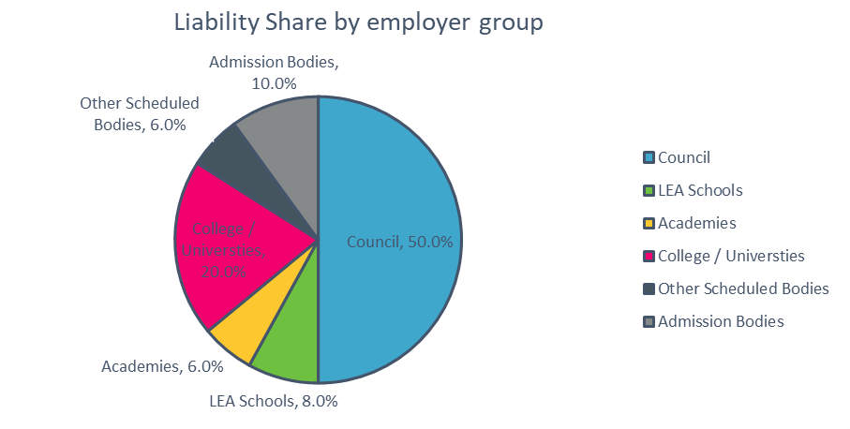

  - The average level of exposure to non-tax raising bodies for the LGPS in general is around 10% based on information provided in Aon’s 2018 report on non-tax raising bodies. This means the Pension Fund has over double the level of exposure than that experienced more generally.

E8. Implications of maturing scheme

  - When the flow of new entrants towards a pension scheme slows it means that, overall, the average age of pension scheme members starts to increase and the ‘duration’ (i.e. time frame) of future cashflows starts to reduce.

  - A consequence of this is that the time horizon that risk can be comfortably taken reduces. This position is compounded if the Pension Fund cannot be 100% confidence in the ability of the employer to make contributions in the future – i.e. when there is a situation where the time horizon for paying benefit starts to shrink and the visibility for being able to rely on future pension contributions is limited, the sensible risk mitigating strategy is to plan to take less risk in the future.

  - This is reflected in the Fund’s general policy of funding ‘cessation’ liabilities (i.e. liabilities without employer backing) on a “least risk” actuarial basis.

  - For the Council’s obligations, this is not a concern, indeed the inflow of new members that are expected to arise out of the in-sourcing of certain contracts may increase the duration of obligations overall for Council – that said, depending on the contribution agreement following the 31 March 2022 valuation discussions, the Fund may switch to being a net dis-investor of assets as benefit outgo starts to exceed income.

E9. The Council

A summary of the approach funding approach adopted for each employer group in 31 March 2019 is provided below, together with a high-level summary of any proposed changes from 31 March 2023.

2019 approach

Funding Consideration | Comment
Funding target | Ultimate target consistent with probability of success of at least 75% based on long-term investment strategy (based on Hymans; proprietary ESS model)
Financial position relative to Funding Target | 78%
Timeframe proposed to reach funding target | 17 Years (assumes at least 70% probability of success)

Overall comment on Council Funding approach

  - Based on provisional results, the funding for the Council’s share of obligations has progressed well. We are not seeking to amend the funding approach for the Council, apart from adjusting the timeframe for meeting the Funding Target to ensure overall stability of contribution rates.

E10. Other Scheduled Bodies (Tax Raising or wholly owned by the Council)

  - Funding approach was consistent with the Council’s. Aggregate Funding for this group was 81% of target at 31 March 2019.

  - Based on provisional results, funding for other Scheduled Bodies has progressed well. We are not seeking to amend the funding approach for other Scheduled Bodies, apart from adjusting the timeframe for meeting the Funding Target to ensure overall stability of contribution rates.

E11. Academies

  - Funding approach was consistent with the Council’s. Funding was 78% of target at 31 March 2019 across all academies. Academies obligations are ultimately underwritten by DfE which means we are comfortable taking a relatively long-term view for this employer group. That said, we still need to be mindful of stability, because it is responsible to do so and a requirement of the regulations.

  - Based on provisional results, funding for academies has progressed well. We are not seeking to amend the funding approach for academies at an aggregate level, however, note comment below which may impact individual academy contribution rates from 31 March 2023.

  - In 2019 contribution rates were set as the average across all academies. Whilst contributions were set as a common rate, asset and liabilities were not pooled. This means that some academies may have been over / under paying relative to their true cost. We believe this approach, whilst easier to administer, introduces risk of systematic under or over funding for some academies.

  - We will therefore be amending the approach so that each academy pays the contribution rate consistent with the liabilities and asset share. We will enter into discussions with academies where the change in contribution rate is more than 2% to discuss whether smoothing would be appropriate.

E12. Admitted Bodies

  - We take a range of approaches for Admitted Bodies, and these are documented within the respective admission agreements and other contractual documentation associated with each employer. Overall, Funding for Admitted Bodies has progressed well and we are not proposing a change to the overall approach. We are also not envisaging a significant change to contribution rates.

  - We have a number of relatively “small” employers joining the scheme with a handful of members (e.g. to service contracts for schools around catering) and the admission process is complex. Over the period to 2025 we will review the admission process to see whether it can be made simpler without prejudicing the overall security of the scheme materially.

  - The Council is looking to in-source a number of contracts over the next few years. All things being equal, this will increase our overall membership and pace at which the Fund grows. Whilst it may increase the overall duration of the Scheme, which is potentially positive from the perspective of us being able to take a long-term view on investments, it also potentially increases risk as the Pension Fund increases in size relative to the employer base.

E13. Universities / Colleges 2019 approach
Funding Consideration | Comment
Funding target | Ultimate target consistent with probability of success of 75% based on long-term investment strategy (based on Hymans; proprietary ESS model).
Financial position relative to Funding Target | 94%
Timeframe proposed to reach funding target | 15 Years (assumes 70% probability of success)

  - We note that the approach taken in 2019 for Universities and Colleges was not significantly different to the approach adopted for the Council (with the core difference being the timeframe to reach target set as 15 years rather than 17 years).

  - Given that the Universities / Colleges do not have the same level of long-term covenant visibility as the Council, the level of risk we are taking is, relatively, much higher. This is compounded given our relatively high exposure to these types of employers as a percentage of the overall Fund.

  - Of potential concern for the 2022 valuation is the level of long-term inflation risk we are exposed to, particularly given our advisors central view on long-term inflation, which is broadly in line with Bank of England long-term targets, but significantly different to that implied by market indicators.

  - We are also aware that steps have been taken by Middlesex University to provide alternative pension provision. This will significantly reduce the flow of new entrants into the Fund. Whilst this will slow the build-up of liabilities for this employer, which is positive from a risk management perspective, it does potentially accelerate the point at which we may need to start planning for cessation and accelerates the maturation of the Middlesex University section of the Fund.

  - As noted in Section 8. above, where the maturation of obligations happens, it is sensible to start to plan to take less risk. This is compounded when there is also a limited level of covenant visibility associated with the employer.

  - Because of this we will be seeking to switch the Funding Target for Middlesex University to a Least Risk funding basis. The timeframe and probability of success will depend on affordability, but provisionally we believe it would be appropriate to target a 15-year time horizon with at least a 60% probability of success.

  - For Barnet & Southgate College we will not be amending the Funding Approach for the 31 March 2022 valuation, but we will keep the situation under review pending the outcome of
mmm111110
Ll!;INDQN 11-UP:Ot.lGH
the Government’s review of whether to provide an underlying government guarantee to Further Education pension liabilities.

E14. Supplementary Information

  - The attached document prepared in conjunction with our advisors sets out further details of:

    - How employer contributions are calculated
    - How assets and liabilities are calculated
    - What happens when an employer joins the fund
    - What happens when an employer leaves the fund
    - What the statutory reporting requirements are

The document also provides further information on the:

    - The regulatory framework around setting a Funding Strategy Statement
    - Roles and responsibilities
    - General risks and controls
    - Actuarial assumptions

Appendix F – Addendum (information provided during consultation)
2022 Valuation

Consultation Update

Introduction of second test to validate contribution decreases

CJBCllmClii
LC:lfGLHJH!l,0.ffC:IU{.H

Introduction

Thts paper sets out rationale for introducing a second test to validate Whether contribution rates should reduce over the period 1 April 2023 to 31 March 2026_

There are several employer groups with different characteristics_ This approach is not being applied to MDX, B&S and contractors.

There are also important technical, legislative and economic considerations relevant to the recommendation_
- The combined result of Hymans' Model + test 2 is that for 1he majority of employers the contribution rate remains consistent with 1he 2019 rate_

The remainder of the paper consider the regulatory and economic context, more information on Hymans' modelling and an explanation of how Test 2 is applied_

In summary:

- Using a time frame of c17 years and a probability of success of 70% within Hymans· Model suggests that contribution rates reduce for most employers.
- Playing in the observed red'11ction in long term real interest rates since 2019, commentary from the Scheme Advisory Board and a general requirement for stability we propose that a second test (test 2) is introduced Whioh uses a slightly shorter timeframe of 15 years and probability of success of 80% - contributions will only decrease if they are assessed to do so under this second test._
CJBCllmClii
LC:IHUOH !1,0.IIC:IU{.H

mmm111110

Legislative and 2019 context

Legislative and regulatory context

The LGPS 2013 regulations each LGPS Fund to put in place a Rates and Adjustment certificate prepared by an Actuary - this is the legal document that imposes a contribution requirement on employers.

CIPFA guidance requires the contribution rate to be prudent

LGPS regu'lations require the method underpinning the rate to be stable_

The Government Actuaries Department ("GAD")
undertake a triennial review of Funds to check for consistency and overall solvency_ GAD will speak to funds where they believe 1here is a fundamental
funding issue.
GAD's analysis shrms that at the 2019 vaIuation, Barnet {the dark blue dot) was amongst least well funded funds (on GAD's standardised basis)_ GAD did
not seek to speak to Barnet because Barnet were also
paying amongst the highest contributions towards their fund.

SAE, rdo>tn"t: funQirif litYCI !!Eillrtst Errpl rrnnlribmlon raoc
Barnet was an outlier from funding perspective
relal!ive,to other F111nds
'"' Relati1"!
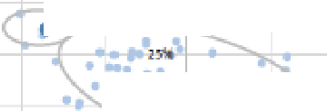

Coottibutions
,, :i----..iL
....._. . .
.
...,
.

.' .
""
Relative Fundn[I

2019 Position

GAD's analysis of the 2019 valumion is shown in the chail to the right
'"'
Fun:ll:l':'1':lr:ir:rtttiJ l1l'RliY.tll)!MU !I flh:ill-1
Source: GAD 201{1Section 13 anal

Wedonohtave informmion to confirm where Barnet sits relatively at 2022, however, whilst we may see some convergence towards the pack, Barnet is still likely to be a marginal outlier.
mmmimmo
LOHUOH ?IOIIOVIJ:.H

Economic and model context

Real Interest Rates

Long-tenm real interest rates are the primary driver for pension costs as 1hey drive expectations around future investment returns. The real 'risk free· yield curve from market data at 2019 and 2022 is outlined below together wi1h Hymans· Economic Scenario Service ("ESS") projection in 17 years time.

Hymans ESS model projects real yields. ris-e ;;md they .ne prqectmg this rise lo be graatef in 2022 lllan llley didin 2DIQ
The chart shows that real market interest rates (the

  - 1.1% (2022 ESS proje<!ed 20 'l""rrate at 2039)
blue (2019} line relative to the red (202 decreased over the three years_This is r Hymans advice where they recommend
rates as follows
in
unt
Discount Rate4.4%
lnnation2.3%
Net rate2.1%
4.6%
2.7%
1.9%
2) lines) enected ed disco
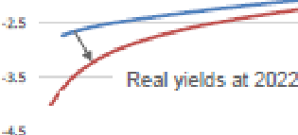
□.8% (2□19 Ess proje<!ed 20 year rate at203!ll However, under Hymans' approach, the contribution
rate is more innuenced by the assumptions embedded within 1he ESS_

.,.,

lower "!hara real
yields. at 2019

Hymans have increased the real Interest rates within the ESS (Blue dot to Red Dot) - i.e.. a reversion to higher rate relative to market indicators.

In summary, this has led to Hymans' model indicating a reduction in contribution rates if we use a timeframe of
17 years and a probabflity of success {under the ESS model) of 70%_
Source: LBS arnalysis I Hymans repo,ts
LOl'tDO 110-IIOUCH
mmmim o

mmm111110
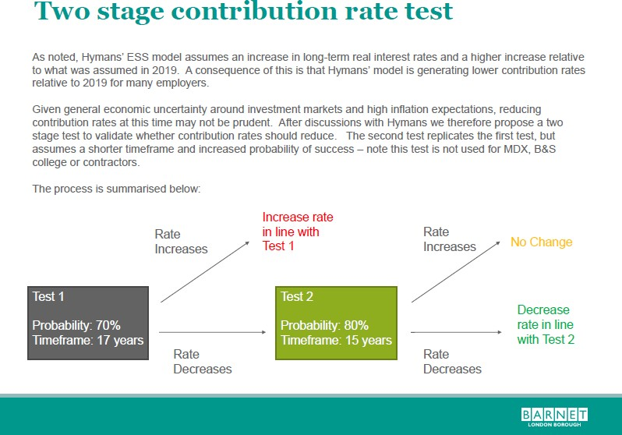
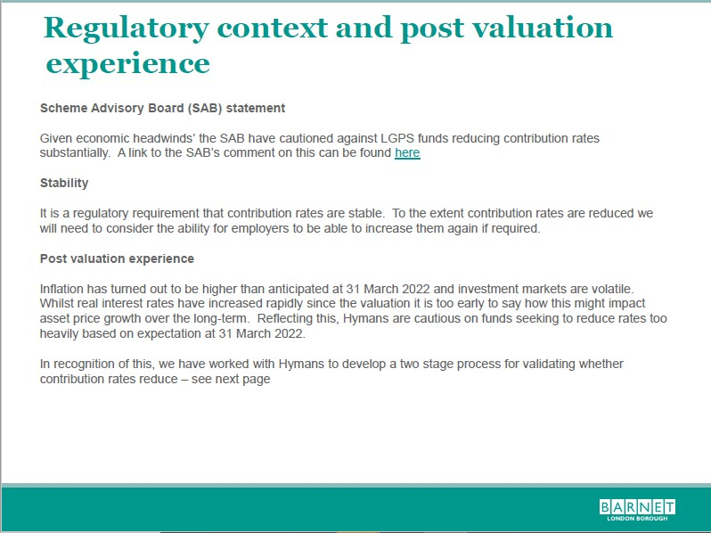

Important Note: Following discussions with the Fund Actuary Test 2 was not fully applied to the Council’s rate. Instead, Officers “paid regard” to the output from Test 2 and increased the Test 1 contribution rate of 27.4% to 28.4% (from 28.9% payable before 1 April 2023).

