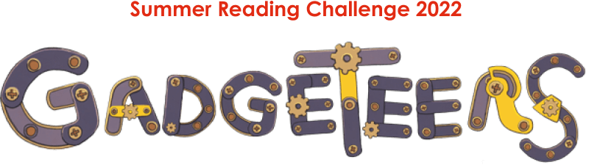

Barnet Libraries - Volunteer Application Form for 14-17 year olds

Completing the Application Form

We’re really glad that you want to volunteer with us. It would help us if you would answer a few questions so we can find out what you want to get out of volunteering with us and how to contact you.

- Please complete ALL the information required in the form.

- When you fill out your form, look at the notes in the Person Specification on the previous page. We are looking for young people who show enthusiasm and commitment to volunteer with us.

- As well as your parent/guardian, you must get one of your teachers or another responsible adult to sign your application form as your referee. Applications will not be considered without this signature.

- If you are successful in your application, you will be given details about when training has been arranged for you at your placement library.

Name: ……………………………………………………………………………………………….

Tel no(s): …………………………………………………………………………………………..

Address: ……………………………………………………………………………………………

…………………….………………………………………………………………………………….

E-mail: ………………………………………………………………………………………………

Emergency contact name: ………………………………………………………………………

Emergency contact no: …………………………………………………………………………..

Please give details of any medical conditions we should know about that may affect your volunteering (we do not exclude anyone because of a medical condition)

………………………………………………………………………………………………………
………………………………………………………………………………………………………
………………………………………………………………………………………………………

Please tell us why you want to volunteer with us

Which library would you like to volunteer at?
Give us your 1st, 2nd and 3rd choice from the following libraries:

Burnt Oak, Chipping Barnet, Colindale, East Finchley, Edgware, Finchley Church End, Golders Green, Hendon, Mill Hill, New Barnet, North Finchley, Osidge, South Friern

1st choice: …………………………………………………..

2nd choice: ………………………………………………….

3rd choice: ………………………………………………….

What skills do you have that might help with your volunteering? e.g. are you creative? Do you have any experience with young children through your family? What other things are you good at?

Is there anything you would particularly like to do as part of your volunteering experience? e.g. talking to children about books, helping out with the art & craft events, reading with children?

Are there any dates when you are not available to volunteer? e.g. you are on holiday

Do you want to be accredited for your volunteering? Yes/No/maybe

Are you already working towards any accreditation that we could help you with? e.g. Duke of Edinburgh Award, NCS, Arts Award? If YES please tell us which one:

Please sign below and ask a parent/guardian and responsible adult to sign this form in support of your application to volunteer with us. A responsible adult is someone who knows you and can be a teacher, youth worker, rabbi, priest, key worker or similar.

Signed (young person): …………………………………….. Date: ………………….

Parent/guardian signature: ………………………………… Date: ………………….

Responsible adult’s signature: ………………………………………………

Responsible adult’s position: ………………………………………………..

Do you think working with children is a suitable role for this applicant? | Yes |  | No

If no, please tell us why? ……………………………………………………………………...

………………………………………………………………………………………………………

Responsible adult’s contact phone number: …………………………….

Date: ………………………….

Please scan and send your completed form via email to natalie.pavlou@barnet.gov.uk

Please put “SRC - Young Volunteers” in the subject line when returning your completed form.

Alternatively, you can post your form to us at the following address –

Natalie Pavlou, Chipping Barnet Library, 3 Stapylton Road, Barnet, EN5 4QT

The closing date for entries is SUNDAY 10 JULY 2022. Please make sure your application reaches us by this date. Due to the high volume of applications we have received in previous years, late submissions will not be considered.

Please don’t hesitate to email Natalie.pavlou@barnet.gov.uk or libraryevents@barnet.gov.uk, with any questions. Good luck!

