RENTAL DETAILS

Community space (D1) Office space (B1)

East Finchley library, 226 High Road N2 9BB

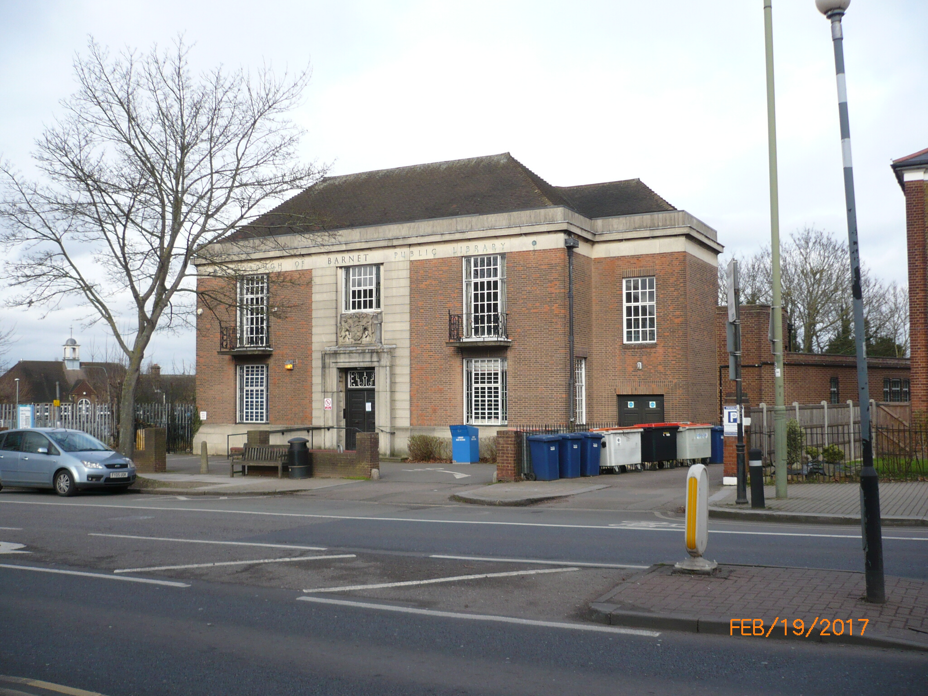

The lettable area consists of ground and first floor space totalling 125 sq.m (1340 sq.ft)

Location

The property is located in Greater London, in the London Borough of Barnet, and lies approximately 0.3 miles from the Golders Green Town Centre, and approximately 8.2 miles north of Central London (Marble Arch).

The property is well served in terms of connectivity, being located with a direct link to the A1 and M1, as well as connections to the A406 North Circular Gyratory. It has good public transport facilities, with the nearest tube station located 0.4 miles to the south of the property at East Finchley station. The location has a high number of bus routes located in close proximity which run directly along the High Road.

The area benefits from a number of local amenities and the area has a number of schools and health care facilities close by.

Lettable area description

The library building has recently been refurbished to provide the two areas of lettable accommodation on the ground and first floors. The ground floor is still being used as a public library.

Please see appendix two for floor plan.

Location plan
Please see appendix 1
Planning
The property has an B1 (office) D1 (office) use. The uses which could be possible under the current planning permission include, nursery, educational and community and standard office use.

Other uses are subject to planning approval. It is advised that all proposals are discussed before submission both with Barnet Council’s Local Planning Authority (020 8359 4974 and 4720 respectively).
Rental terms
By negotiation but the council envisions a lease of approximately 10 years at a passing rent in the region of £20,000 per annum (exclusive of business rates and service charges).
Costs
The prospective purchaser or tenant will be responsible for the Council’s legal and surveyor’s fees.
Further Information in regards to this property please contact :
Alex Hill – Barnet Estates/Property Services | 0208 359 2774
London Borough of Barnet  Barnet House, 1255 High Road, N20 0EJ. | Alex.hill@barnet.gov.uk

General Information
1. The areas and measurements contained within these particulars are approximate figures only and no warranty is given as to their accuracy. The prospective tenants should satisfy themselves as to site areas and other matters of measurement from their own inspections and surveys. These details do not form part of any contract.
2. All statements made herein are made without responsibility on the part of the London Borough of Barnet and its employees, and should not be relied upon as statements or representations of fact. Prospective tenants must satisfy themselves by inspection or otherwise as to the correctness of each of the statements contained in these particulars.
3. The London Borough of Barnet and its employees do not give any warranty whatsoever in relation to the property.
4. The property will be leased as seen with all latent and patent defects and neither the London Borough of Barnet nor its employees warrant that it is suitable for any proposed use.
5. In no case shall any prospective tenant have any claim for expenses incurred in the preparation of any offer, nor in respect of any other matter.
6. The Council is not obliged to accept the highest or any offer received.

Appendix 1

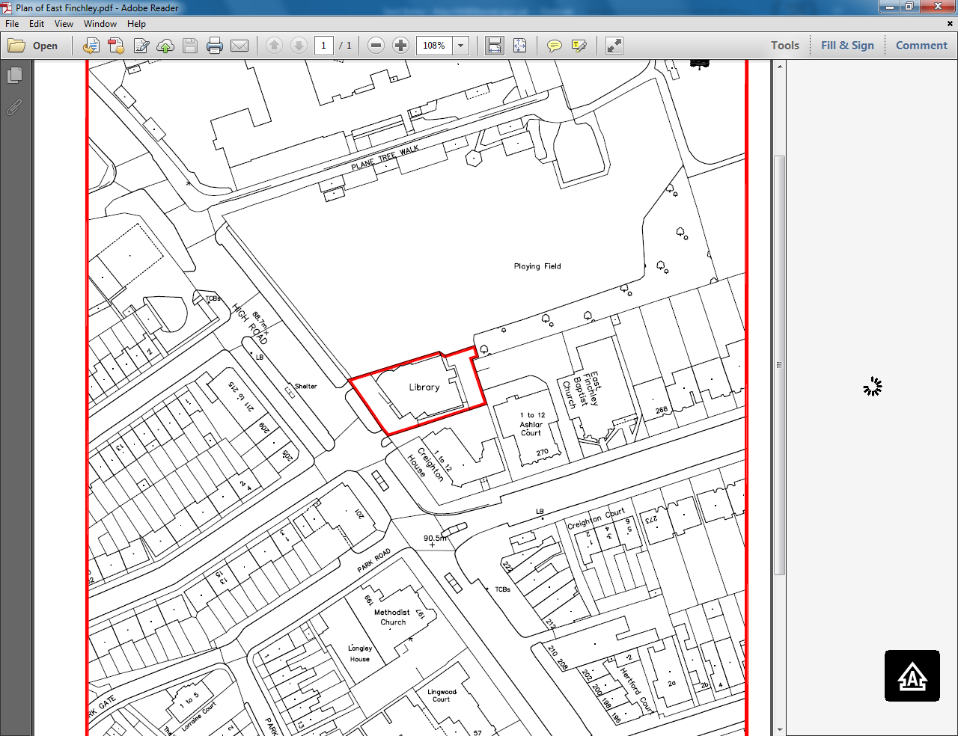

Appendix 2

