ENTAL DETAILS

Community space (D1), ground floor

Community Centre, Tarling Road, East Finchley N2

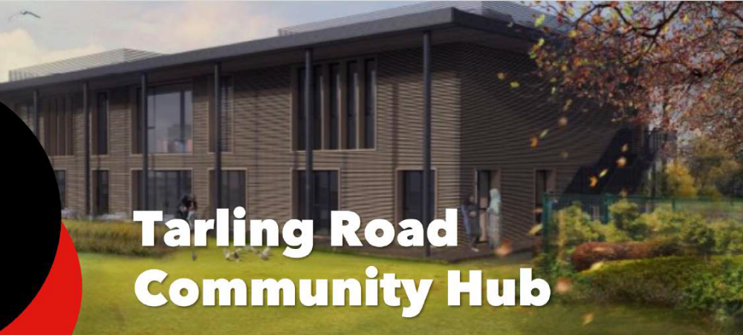

The lettable area consists of ground floor space only totalling 173 sq.m (1,862 sq.ft)

Location

The property benefits from good public transport facilities the nearest tube station, East Finchley (Northern line) is located 1 mile to the south of the subject property. There are also a high number of bus routes located in close proximity on High Road.

The community centre is located in an area consisting mostly of privately owned houses and low rise blocks of apartments.

Lettable area description

A new community centre is currently under construction and is scheduled for completion in Autumn 2018. The building will act as a community hub with rooms/halls available for temporary letting with other spaces allocated for long term occupation.by potential community providers/groups.

The area available to let is located on the ground floor of the building and provides space which includes kitchen facilities, staff room, reception, storage space, cloak room, independent toilets and wash facilities totally 173 sq. m.
The space will be fitted out to a basic modern standard and the tenant will be expected to carry out any additional works if required.

Please see Appendix 2 for a plan of the proposed lettable area.

Location plan
Please see appendix 1 (Subject property marked with a red star)
Planning
The property has an established D1 use. The uses which could be possible under the current planning permission include, nursery, educational and community use.

Other uses are subject to planning approval. It is advised that all proposals are discussed before submission both with Barnet Council’s Local Planning Authority (020 8359 4974 and 4720 respectively).

Rental terms
By negotiation but the council envisions a lease of approximately 25 years at a passing rent in the region of £37,250 per annum (exclusive of business rates and service charges).

Costs
The prospective purchaser or tenant will be responsible for the Council’s legal and surveyor’s fees.
Further Information in regards to this property please contact :
Alex Hill – Barnet Estates/Property Services | 0208 359 2774
London Borough of Barnet  Barnet House, 1255 High Road, N20 0EJ. | Alex.hill@barnet.gov.uk

General Information
1. The areas and measurements contained within these particulars are approximate figures only and no warranty is given as to their accuracy. The prospective tenants should satisfy themselves as to site areas and other matters of measurement from their own inspections and surveys. These details do not form part of any contract.
2. All statements made herein are made without responsibility on the part of the London Borough of Barnet and its employees, and should not be relied upon as statements or representations of fact. Prospective tenants must satisfy themselves by inspection or otherwise as to the correctness of each of the statements contained in these particulars.
3. The London Borough of Barnet and its employees do not give any warranty whatsoever in relation to the property.
4. The property will be leased as seen with all latent and patent defects and neither the London Borough of Barnet nor its employees warrant that it is suitable for any proposed use.
5. In no case shall any prospective tenant have any claim for expenses incurred in the preparation of any offer, nor in respect of any other matter.
6. The Council is not obliged to accept the highest or any offer received.

Appendix 1

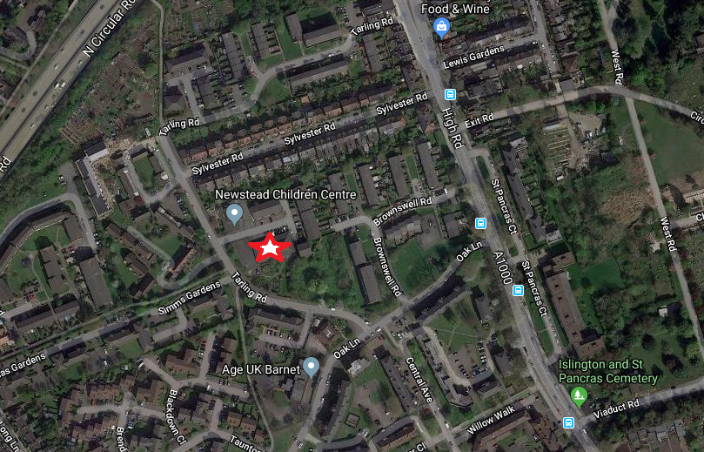

Appendix 2



