Do you use adult social care?
Do you use health services?
Join People Bank
Get involved and have your say. We need you!
What is People Bank?
- People Bank is the name for a group of people who use adult social care or health services in Barnet.

- We need your help to make our services better.

- You will work with the Council and health services to make changes.

- You can get involved as much or as little as you want.
What will you get when you join People Bank?
- A regular newsletter telling you about ways to have your say

- Invitations to the Annual Summit. This is a big event to help decide what areas are most important over the next year

- A chance to join working groups and make a change on topics that are most important to you.
How can I join?
Fill in the form below and send it to:

Engagement Lead
Adults and Communities
Barnet House
1255 High Road
London N20 0EJ

People Bank form

 | Contact details
 | Name:
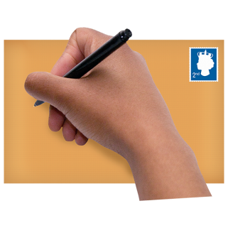 | Address:
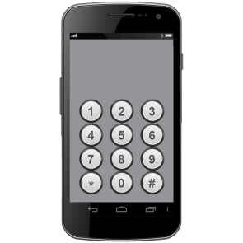 | Phone:
 | Email:
 | How should we contact you? (Please tick)
 | Email Letter Phone

 |  |  | Do you need any extra support? (Please write in the box)
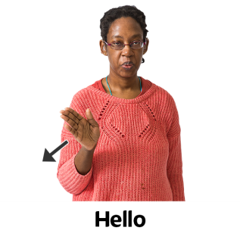 |  |  | For example:  Do you need Easy Read?  Can you only come to places with no stairs?  Do you need a sign language interpreter?
 |  |  | I am a: (please tick the right box for you)
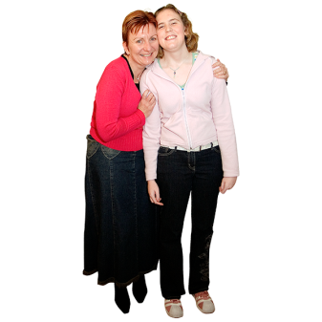 |  |  | Carer (I support someone else)
 |  |  | Service user (I use social care or health services myself)
 |  |  | Voluntary sector representative (I work or volunteer for a voluntary group or charity)
 |  | I am interested in: (please tick as many as you want)
 |  | Autism
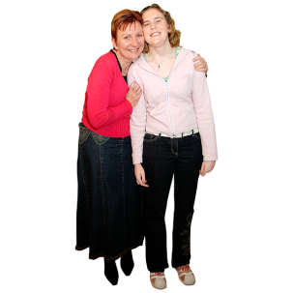 |  | Caring for someone
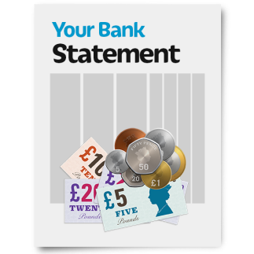 |  | Direct payments
 |  | Health improvement
 |  | Learning disability
 |  | Long term illnesses (like heart disease or diabetes)
 |  | Mental health
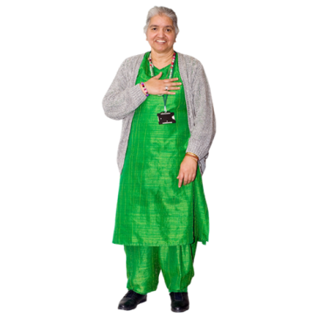 |  | Older people
 |  | Physical disabilities
 |  | Sight/hearing loss
 |  | Other issues

 |  | Please contact me about: (please tick as many as you want)
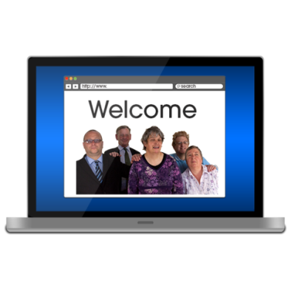 |  | Online surveys
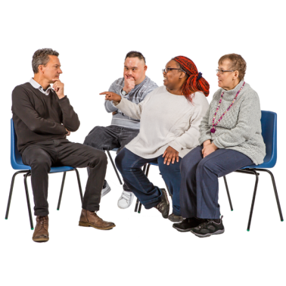 |  | Council consultations (big surveys)
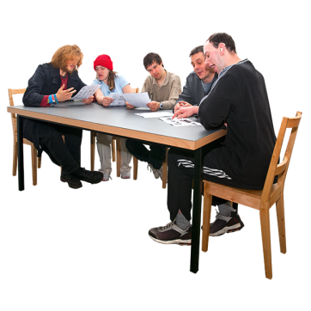 |  | Meetings and working groups
 |  | Events
 |  | Where did you hear about People Bank?
 |  | How will we use your personal information?
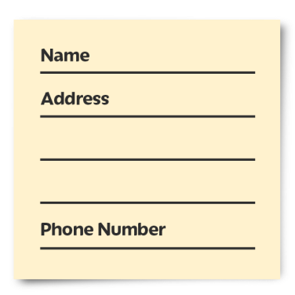 |  | We will make sure to keep information like your name and address safe unless there is a very important reason in the law that we need to share it.  We also want to share your details with Barnet Clinical Commissioning Group (BCCG). They are in charge of health services in Barnet.  Please tick if you agree to us sharing your information with BCCG. If you agree they can contact you about chances to have your say about health services.  You can still be a member of the People Bank even if you don’t agree to share this information.

If you have any questions please email engage.adults@barnet.gov.uk or call 0208 359 4712.

