

Learning Disability Partnership Board

Minutes

Meeting on 09th December 2014, 12.30pm – 4.30pm
Committee Room 1, Hendon Town Hall.

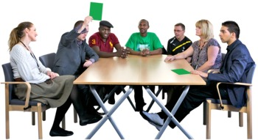

Present
Karen Morrell | Head of Integrated Care: Learning Disabilities and Mental Health (LDPB Co-chair)
Mahmuda Minhaz | People’s Choice (LDPB Co-chair)
Ray Booth | Chair of the Carer’s Subgroup
Steyn Crous | Healthwatch Barnet
Bernice Davis | Chair of the Housing Subgroup and Voluntary Sector Representative (Business Meeting only)
Rhoda Fynn | Carer Representative
Shelley Gibbons | Co-Chair of Day Opportunities and Community Inclusion Subgroup
Kevan Hall | Service User Rep
Richard Harris | Chair of the Speaking Up Subgroup
Gill Fosler | Volunteer, BCIL
Maria Nash | Carer Representative
Chhaya and Rakhal Saha | Carer Representative
Anthony Nicholson | Carer Representative
Phillip Rackham | Service User
George Christodolou | Carer Representative
Lizzie Reeder | LD Parliament
Sue Tomlin | Joint Commissioning Unit
Stuart Downie | Disability Employment Advisor, Job Centre Plus
Peter Nyamekeh | Working for You
Sarah Khalid
Lyn Huddleston | Flower Lane Resource Centre
Ruth Carter | Service User Rep
Shilpa Shah | Peoples Choice
Andrea Constantinou | Peoples Choice
Sandy Littman | Carer Representative
Jenne Patel | Commissioner, Joint Commissioning Unit
Caroline Glover | Commissioner, Joint Commissioning Unit
Lara Goldbart | LD Parliment
Apologies
James Evans | BCIL
Susan Hawthorne | Healthwatch Barnet
Betzalel Lifschitz | Service User
Molly Rayment | Chair of Health Development Subgroup
Lorna Fahy | Public Health

1.   | Welcome, Apologies and Introductions  Mahmuda welcomed everyone to the meeting. Hannah told everyone about the people who had apologised that they couldn’t be there today.
2.  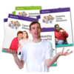 | Workshop: Welfare Benefits  Shelley Gibbons introduced her colleagues Stuart and Peter and Mary.  Shelly told everyone that there was a quiz on some of the most important benefits . It was not important if you knew all the answers as they would be explained afterwards.  Everyone had a go at the quiz and lots of people knew the answers. The quiz and the answers and the factsheet can be seen in appendix 1 at the end of these minutes.  The quiz and answers sheet is available in appendix 1.  Personal Independence Payment(PIP)  This is the benefit that will be received instead of Disability Living Allowance. It will have two sections, Care, and Mobility and will have two rates in each section called standard and enhanced.  This is being rolled out over many years and it will be by postcode. You will get a letter if you already get Disability Living Allowance to ask you to fill in a form to apply for PIP  There is going to be an appeal system but nobody knows what this will look like yet as it hasn’t happened.  Employment Support Allowance (ESA)  There are two groups in this benefit:  Work related activities group- you will have to work with an organisation to help prepare you to work towards being able to look for a job  Support Group – You do not have to do anything to look for a job if you are in this group.  Other benefits that were spoken about were Housing Benefit, Working Tax Credit, Child Tax Credit, Job Seekers Allowance (JSA)  Soon a benefit called Universal Credit will start to be used which will replace all of the benefits except PIP.  It will start to be used in Barnet in February with a very small group of people who don’t work but also don’t claim housing benefit and will only be used for people who claim for the first time.  A question was asked how people could work when there were no jobs.  Support available to help people find work will be spoken about in Barnet Mencap’s presentation later in the meeting  A question was asked if people will be better off with their money if they find a job.  Working for you and the Job Centre will be able to help work out if you will be better off to find a job than stay on benefits.  A question was asked that when the changeover happened from Disability Living Allowance to Personal Independence Payments if this would have any effect on the Fairer Contributions Policy for people in receipt of Social Care.  Karen stated that she did not know the answer but she would take this away  Action 1 – Karen to find out if the change in Benefits from DLA to PIP will have any impact on the Fairer Charging Policy.  Stuart Downie also pointed out if people needed help to get to and from work or needed help in work this is something an organisation called Access to Work may be able to provide. They are also able to provide travel training in advance of someone getting a job to help them learn to get to work independently.
BUSINESS MEETING
1.  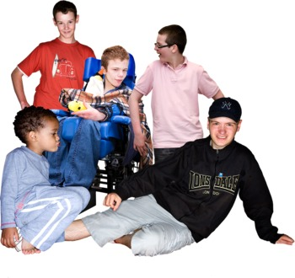 | Services for People aged 0-25  Karen told everyone that she only has a short update on what is happening for people aged 0-25 with a disability in Barnet.  Lots of work has been taking place but no final decisions have been made yet. All of the boroughs in the country have been asked to look at all the services for people of this age group and make sure the services meet the needs of everyone.  People who are born with a disability will need to have an education, health and care plan that will be updated throughout their life until they are 25  Barnet are currently deciding how they will provide this service and if it will be delivered by on service. They are looking at who may need to be a part of this service.  Kirk Chamberlain is leading on this and is asking young people what they think and working with key people in children and adult services.  It has also been identified that it is important to work with what young people with disabilities want to achieve in their lives so that they are not reliant on services.  Karen said she will ask Kirk to come to the next Partnership Board and speak about what will be happening next  Action 2- Karen to invite Kirk to speak to the Board at the next meeting about the 0-25 service.
2.  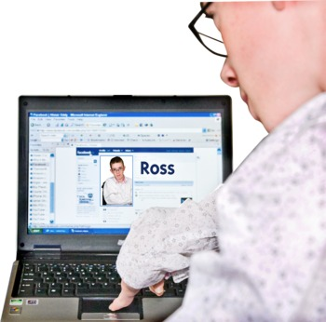 | Using Information Technology to share the Learning Disability Partnership Boards work.  Karen asked the board to think about how we use more information technology to share the work that the board is doing both with other boards and with the wider public.  There was a suggestion that we could use Twitter to spread the message more widely.  There were other suggestions that we could have a Facebook account.  It was asked not to forget those people that did not use internet technology.  Hannah fed back there would soon be a monthly update via email and in the post for those that request it. This would bring together important information to all the partnership boards.  It was suggested that it would be helpful to know where there were courses in the borough that would be able to help people learn to get online  Action 3: Hannah to feedback request to the communication team about using twitter to spread the message of the partnership boards.  Action 4: Hannah to send out where online courses can be found in the borough as part of the monthly update.
3.   | Barnet Mencap’s Bright Futures  Ray Booth introduced a new service from Barnet Mencap.  It started on the 1st of October and is open to anyone with a Learning Disability or Autism.  The service is split into 4 parts  Working for you:  This is a drop in that provides support and information and advice  COPS:  This is aimed around leisure and learning and has lots of contacts in the community. They are due to begin working with Southgate soon.  Employment:  Provides 1-1 support to help people who are ready to look for work find it, and help those who want to work get ready to look for work.  They have currently started a you tube channel which will be run by the people they support.  Training and Awareness  Ray asked people to share ideas with them about where may be good places to share information about the project  There were suggestions that good places to put information would be churches, libraries, community newsletters, shopping centres and supermarkets.  One suggestion was that as this was an on-going project that stalls could be set up at the summer festivals around the borough during the summer.  Another suggestion was that Barnet Council should publicise things on a wider level with notices on bus stops and in the newspapers.  Action 5 – Hannah to provide feedback from the communications team if they can support with this.
4.   | Health and Well-Being Board forward work plan.  The Health and Well-Being board make important decisions about health and social care in Barnet.  They have asked that all the boards look at what they are doing in the future and to feedback what you think is important for people with Learning Disabilities. Karen shared the board’s priorities for the next few months.  Action 6: Board members to tell Hannah what they think is important for the Health and Wellbeing board to know.
5.  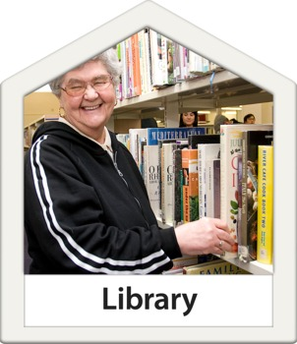 | Libraries  Helen and Elissa came to tell everyone about the future plans for the library service  They explained that they wanted to continue providing a good quality service but that they had less money to do it with.  They explained what services would stay the same and what things would change.  They explained that three proposals had been put forward as possible ways to keep as many libraries open as possible. Some of the ideas were to shut some libraries and make others bigger or to keep all the libraries open but change who may run them.  One of the suggestions was to make some of the time the libraries were open to have them unstaffed.  Lots of people at the meeting did not think this was a good idea and raised concern that this would not be safe for people with Learning Disabilities.  There was also concern raised that if libraries were smaller that there would not be room for people in wheelchairs.  Helen and Elissa advised that any redesign of the buildings would be done with people with disabilities in mind.  There were concerns raised that the consultation would not be meaningful and that the views of people would not be listened to.  Karen reminded everyone not to guess what would happen and make sure that they get involved with the consultation so that they could put their views across.
6.     | Feedback from the Autumn Catch Up  It was raised that it was important that Debbie Frost had said that we could communicate with GP’s via their weekly bulletin.  Hannah advised that the issue of not feeling connected with the GP’s was something that had come up on all the tables and was something that will be discussed with all of the co-chairs.
7.   | Sub Group Updates  Stuart was not able to stay to give his update on employment and so Ray gave it on his behalf.  Ray told everyone that the group had a good meeting in the summer but that it had been struggling to have regular attendance and so the meetings had been difficult to do.  Ray told everyone that the group will be looking for a new chair so that the good work can continue  Sue gave an update on the Health group on behalf of Molly who wasn’t able to make the meeting.
9.   | LD Parliament Update  Lara gave an update for the LD Parliament. The main points were:  - The Parliament is still working with the Brent Cross project to make sure the new building is accessible for people with disabilities  - The Parliament has asked Mencap and Dimensions to work together on the workshops on helping people with learning disabilities to vote.  - The Parliament is trying to recruit new members from organisations that represent minority groups
10.  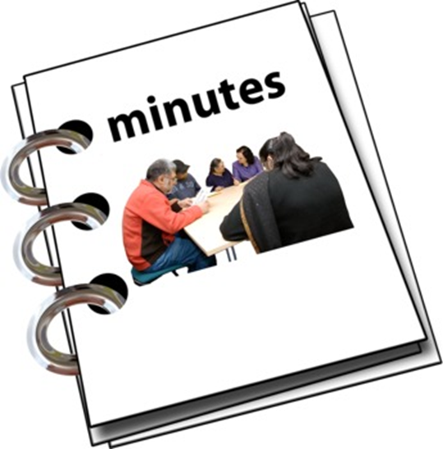 | Review of actions from draft minutes  The minutes were sent out before the meeting.  It was raised that the last meeting was held at Hendon Town Hall and not at Barnet House as the minutes had said. It was also asked if Gill Fosler could be added to the apologies list.  The minutes were agreed apart from this.  The actions were looked at and any that had been completed were taken off the action log.
11.   | Any other business  The Autism Awareness day was successful and people enjoyed it and there were lots of people from different places who came to the day.  There were lots of views but some people said that there was not enough time.  The group are looking at ways to make sure everyone can stay involved.  It was asked if the Chairman of Barnet Mencap could attend the next Board meeting to celebrate Mencap’s anniversary next year. Ray advised that this may not be able to happen but that they would be running lots of celebrations and Ray will tell the board about them next time.  An issue was raised that there had been a problem with a carers discharge from hospital and the concern was raised that all the good things the board talks about with regards to carers is not happening in reality. Karen agreed to speak about this outside of the meeting and chase this up.
  12. | Important things we want to tell other Partnership Boards about LDPB’s work  It was felt it was important that it should be remembered about the important role family carers play in people with learning disabilities  It was also raised that it is important when communicating with people with learning disabilities to remember to use plain English and put pictures in if possible,
15.   | Feedback Forms  Hannah apologised for not bringing the feedback forms and stated she would send them to everyone to be able to fill in and return.
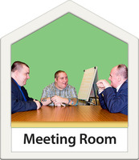  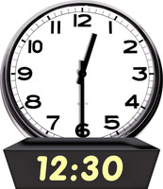 | Next meeting:  Tuesday 17th March  12:30 -4:30,  Committee Room 1, Barnet House

LDPB Actions Log

Date Agreed | Action Number | What LDPB has agreed to do | Who will do this action
09th December 2014 | 1 | Karen to find out if the change in Benefits from DLA to PIP will have any impact on the Fairer Charging Policy. | Karen Morrell
09th December 2014 | 2 | Karen to invite Kirk to speak to the Board at the next meeting about the 0-25 service. | Karen Morell
09th December 2014 | 3 | Hannah to feedback request to the communication team about using twitter to spread the message of the partnership boards. | Hannah Ufland
09th December 2014 | 4 | Hannah to send out where online courses can be found in the borough as part of the monthly update. | Hannah Ufland
09th December 2014 | 5 | Hannah to provide feedback from the communications team if they can support with this. | Hannah Ufland
09th December 2014 | 6 | Board members to tell Hannah what they think is important for the Health and Wellbeing board to know. | All members
16th September 2014 |  | Gary Johnson to provide an easy read briefing on the ILF changes to LDPB | Hannah Ufland
17 June 2014 | 3 | Let Ray or Karina know things we can do to get more people to come along to subgroups. | Everyone
18 March 2014 | 4 | Think about what subgroups can do to make things better for family carers when developing their workplans. | Subgroup chairs
Date Agreed | Action Number | What LDPB has done.  (All these actions have been done.) | Who has done this action
16th September 2014 |  | Barnet People’s Choice to let everyone know about Caroline Rossi’s memorial service and how to donate to the trust being set up. | People’s Choice
16th September 2014 |  | Everyone to send their ‘stories’ about eye care to Jo: jo.dutch@barnet.gov.uk and Subgroup chairs to ask people in their subgroups to give Jo their stories about eye care. (Jo to make an email for subgroup chairs to send to their members.) | Everyone
16th September 2014 |  | Karen to update Board on Learning Disability Service as there is information to share. | Karen Morrell
16th September 2014 |  | Molly to circulate the link to more information on the Confidential Inquiry to LDPB. | Moll Rament
16th September 2014 |  | Shelley to provide information on the workshop about voting to LDPB members. | Shelley Gibbons
16th September 2014 |  | Perpetua to tell Board members the new date for the Autism workshop. | Perpetua
17 June 2014 | 1 | Arrange for somebody from the LD Service to go to the Speaking Up Subgroup to talk about reviews. | Karen Morrell
17 June 2014 | 2 | Send ideas about the ‘How Are We Doing?’ Day to Perpetua. | Everyone

Appendix 1

Benefits Quiz

1 | 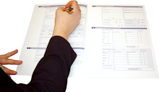 | What does DLA stand for?
2 |  | DLA is changing, do you know what it is changing to?
3 | 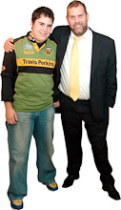 | What benefit can a carer claim?
4 | 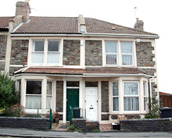 | What benefit can you get to help pay your rent?
5 |   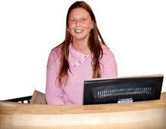 | If you are working what may you be entitled to if you are on a low wage?
6 |  | How many rates does Personal Independence Payment have?
7 |  | How many components (parts) are there to DLA?
8 |  | If you can’t work other than DLA what may you be entitled to?
9 |  | If you lose your job what benefit could you claim?
10 |    | If you don’t attend appointments at the Job Centre what could happen?
11 | What one benefit will replace all of these?
   |  | 
  Income-based Jobseekers Allowance | Income-related Employment and Support Allowance | Income Support
  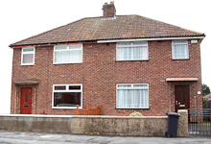 |  | 
  Housing Benefit | Working Tax Credit | Child Tax Credit
12 | 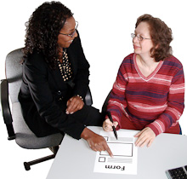 | If you get a Personal Budget, which one Barnet organisation run by disabled people can offer you free and independent support to help you decide how to use the budget?
Quiz Answers

1. |  | DLA stands for Disability Living Allowance - it is a benefit that helps with the extra costs of disability or a long-term illness.
2. |  | Personal Independence Payment (PIP) - a new benefit which will eventually replace DLA. PIP is for adults (aged 16-64) with disabilities or a long - term illness.
3. |  | Carer's Allowance - it is a benefit for someone who spends at least 35 hours a week caring for a disabled person who receives a Disability Living Allowance at middle or higher rate of care component or PIP.
4. |  | Housing Benefit - benefit for people on low income to help them to pay their rent.
5. |  | Working Tax Credit - a payment for people who work and have a low income. You need to work a certain number of hours a week to qualify. You can get even more money if you are getting DLA or PIP.
6. | 2 | Personal Independence Payment components have two rates: a standard rate and an enhanced rate.
7. | 2 | DLA has two components (parts): a care component and a mobility component.
8. |  | Employment and Support Allowance - it is a benefit for people who cannot work because they are ill or disabled.
9. |  | Jobseeker's Allowance - a benefit for people who do not have a job and are actively seeking work.
10. |  | Benefit sanctions - your benefits may be cut, suspended or stopped if you do not attend appointments at Job Centre.
11. |  | Universal Credit - a benefit that will eventually replace Working Tax Credit, Child Tax Credit, Jobseeker's Allowance, Housing Benefit, Employment and Support Allowance and Income Support.
12. |   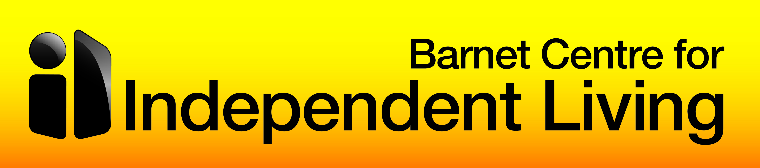 | If you need any help with your Personal Budget, you can contact Barnet Centre for Independent Living (BCIL) on 020 8359 2444.  Address: Barnet Centre for Independent Living, The Concourse, Grahame Park, Colindale, London NW9 5UX)

Factsheet

Other things available for people with learning disability and their carers∗

Benefits:


- Income Support - a means-tested benefit for people who have no income or are on low income

- Child Tax Credit - a payment available to people with children. You may be entitled to Child Tax Credit no matter whether you work or not as long as your household income does not exceed a certain limit.

- Attendance Allowance - a benefit for people aged over 65, who have a disability or long-term illness.

- Disability Premiums - if you and/or your child receive DLA or PIP, you may be entitled to premiums (extra money) in means-tested benefits, i.e. Income Support, Employment and Support Allowance, Working and Child Tax Credits, Housing Benefit, Job Seeker's Allowance, etc.

- Carer Premium - if you care for a disabled person you may be entitled to an extra amount of money in means-tested benefits; for example if you get Carer's Allowance or you are entitled to it, you may get extra amount of money in Housing Benefit (about £34 a week)

Help with paying energy bills:


- Cold Weather Payment - a government grant given to certain qualifying households. Payments of £25 for each seven day period are made when the local temperature drops below zero degrees Celsius for 7 consecutive days between November and March.

You can use this website: http://pensions-service.direct.gov.uk/en/cold-weather-payment/ to check which areas are set to receive the Cold Weather Payment

Eligibility criteria: receiving Income Support, Pension Credit, Income- based Jobseeker's Allowance, Income-related Employment and Support Allowance (with JSA and ESA only if you receive Child Tax Credit, a disability or pensioner premium or have a child under 5 or a disabled child) or Universal Credit (only if you are not working, or you have a disabled child or a child under 5, or receiving a limited capability for work element)

There is no need to claim - the Cold Weather Payment will be paid automatically to your account.


- The Winter Fuel Payment - tax-free payments between £100 and £300 to help with heating bills for people born on or before 5 July 1952

Eligibility criteria: State Pension and other social security benefits

Usually payments are made automatically between November and December.

- The EDF Energy Trust and The British Gas Energy Trust - grants to individuals and families to clear domestic gas and electricity debts owed to various suppliers, to buy essential energy efficient household items (e.g cookers, washing machines), to help with Bankruptcy Deposits/Debt Relief Orders

Eligibility criteria: vulnerable families and individuals who are struggling to pay their energy bills, experiencing crisis and financial hardship

websites: http://www.edfenergytrust.org.uk/
http://www.britishgasenergytrust.org.uk/

Freedom Pass for Disabled People
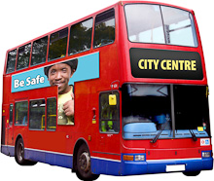
Free travel on busses, trains, trams, tubes and Dockland Light Rail services in London

Eligibility criteria: people who are: blind or partially sighted, profoundly or severely deaf, having no speech, having disability which affects their ability to walk, having learning disability, people who do not have arms or cannot use both arms, people whose application for the Driving License was refused on medical grounds.

Some London boroughs may issue Discretionary Freedom Pass to disabled people who do not meet one of the statutory eligibility criteria.

website: http://www.barnet.gov.uk/forms/form/191/en/freedom_pass_for_disabled_people

Disabled Persons Railcard
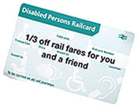
1/3 off most rail fares across Britain – costs £20 for one year or £54 for three years.

Eligibility criteria: receiving DLA or PIP or Severe Disablement Allowance, registered as having visual impairment or as deaf or using a hearing aid, having epilepsy, buying or leasing a vehicle through the Motability scheme

website: http://www.disabledpersons-railcard.co.uk/

Motability scheme

The Motability scheme enables disabled people to lease a new car, scooter or powered wheelchair using their DLA/PIP mobility component.

Eligibility criteria: receiving higher rate mobility component of DLA or Enhanced Rate of the Mobility Component of PIP or Armed Forces Independent Payment or War Pensioner’s Mobility Supplement

website: http://www.motability.co.uk/

Road Tax Exemption and Reduction

Free car tax in a disabled class

Eligibility criteria: higher rate DLA Mobility component, War Pensioners Mobility Supplement, Enhanced Mobility PIP (100% exemption) or Standard Mobility PIP (50% reduction)

websites: http://www.disabledmotoring.org/dmuk/home
https://www.gov.uk/financial-help-disabled/vehicles-and-transport

Blue Badge Scheme
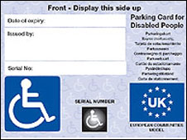
The Blue Badge scheme is for drivers and passengers with mobility problems. The scheme enables Blue Badge holders to park their vehicle in restricted areas.

Eligibility criteria: People eligible without further assessment (automatic entitlement):
- registered blind/severely sight impaired
- receiving the War Pensioners' Mobility Supplement
- receiving the higher rate of mobility component of DLA
- receiving the mobility component of PIP and scored at least 8 points in relation to the 'moving around' activity in the PIP assessment or at least 12 points in the mobility activity for planning and following journeys
- received a government grant towards own vehicle
- have been awarded a lump sum benefit from the Armed Forces Compensation scheme

People who may be eligible subject to further assessment (if none of the above apply):
- have permanent and substantial disability which causes considerable difficulty in walking or inability to walk
- drivers with severe upper limbs disabilities
- there are special rules for applying on behalf of a child under the age of 3

website:
http://www.barnet.gov.uk/info/274/blue_badge_parking_permits/378/blue_badge_parking_permits

Cinema Card

Free cinema tickets for an accompanying carer in most of UK cinemas.

Eligibility criteria: receiving DLA or PIP

website: https://www.ceacard.co.uk/

VAT relief for disabled people

No VAT charged on products designed or adapted for disabled person’s own personal or domestic use. In addition VAT will not be charged on repairs or maintenance, spare parts or accessories, the installation and extra work needed as a part of this.

Eligibility criteria: physical or mental impairment that affects one’s ability to carry out everyday activities, or chronic illness (i.e diabetes) or terminal illness

Examples of qualifying products or services: wheelchairs, stairlifts, alarms, adjustable beds, motor vehicles or the leasing of a motability vehicle, medical appliances, building work like installing a lift, ramps, etc., low vision aids, braille paper, etc.

website: https://www.gov.uk/financial-help-disabled/vat-relief

 Please note this list is not exhaustive. You can seek advice about other services and benefits you may be entitled to

