Strategic Equalities Objective and Measures
Quarter 4 Report

Background

As part of the 2010 Equality Act, the council is required to publish a Strategic Equalities Objective and to provide an annual report of progress. The council published its Strategic Equalities Objective as part of the 2013– 2016 Corporate Plan. The objective is enshrined in the constitution and states that citizens will be treated equally, with understanding and respect; have equal opportunity with other citizens; and receive quality services provided to Best Value principles.

Barnet’s Approach to Equalities is to:
- Embed Equalities considerations into everything we do.
- Assess the equalities impact of our proposals and use this in decision making.
- Use evidence and data to understand service users, impact, trends and gaps in service design and delivery.
- Know and engage with our communities and build on community strengths to optimise independence and support people to take control of their own lives.
- Check how we are doing and monitor our performance against equalities objectives and resident satisfaction and publish the information.

Barnet has introduced corporate performance indicators to monitor the strategic equalities objective in four key areas:

- Customer satisfaction
- Employment
- The accessibility of new homes
- Life expectancy and health

Highlights

In a period of austerity when Barnet has made cumulative savings of £72.5m since 2010 and has indicated that further savings of £70m must be found by 2020:

- Satisfaction with Barnet remains high -87% of residents are satisfied with their local area as a place to live. This is 4 percentage points above the national average.

- Community cohesion is increasing with 84% of residents agreeing that people from different backgrounds get on well together in the borough, and 78% of residents feel there is not a problem or not a very big problem with people not treating each other with respect and consideration.

- Unemployment in Barnet at 6.4 % is approximately 2 percentage points below the London figure. There have been improvements in employment opportunities for young people not in employment education and training and the unemployment rate for this group is 2.3% This is the fourth lowest figure in the country and well below the London figure of 3.8%.

- There has been a 21% reduction in job seekers claims in Barnet. Benefits claimants in Barnet at 9.8% are below the London average of 12.2%.

- Borough performance on Lifetime Homes has improved since October 1st 2013, the launch date of Re. There has been an improvement in the number of wheelchair accessible homes and those meeting the lifetime homes standard. Just under 80% of new homes approved in 2013/14 will deliver Lifetime Homes standards compared with 65% in 2012/13. Wheelchair Homes were 7.4% of new homes approved. Re is also focussing on equal opportunities and undertaking an equalities impact assessment in the review of housing strategy following changes in housing legislation and welfare reform.

- Overall there have been some health improvements in Barnet- most notably child health outcomes outperform the London average and under 65 deaths from Cardio Vascular Disease continue to fall but life expectancy is only slightly increasing with a slight decrease in the gap in life expectancy between the richest and the poorest.

- The key area where we think we can do better is on our engagement with residents. The Resident Perception Survey shows a downward trend against the indicator ‘the council doesn’t do enough for people like me’. Overall 55% do not feel that the council does enough for people like me. There are significant variations beneath this with almost two thirds of people with a limiting long term illness of disability sharing this perception together with people who have lived in the borough for a longer period of time (over 20 years). The areas that are most likely to feel this way are Hendon, Colindale, West Finchley and Underhill.
- We are not happy with the direction of travel on this indicator and we want to understand the meaning of it. We will undertake further analysis to understand the reasons behind this perception.

How are we doing?
The corporate performance indicators are listed by the Corporate Plan objectives:

1. Promote responsible growth, development and success across the borough
1.1 Reduce the employment gap between different groups of residents including those with protected characteristics.
- The overall unemployment rate in Barnet is 6.4%, this compares to a London rate of 8.5% (Source: NOMIS, Dec – Jan 2013)
- 11.8% of Barnet’s working age population have a disability (Source: Annual Population Survey (NOMIS), Jan – Dec 2012).
- Limited data is available to allow analysis by age, ethnic group and religion to assess whether there are any notable employment gaps between these groups. However the 2011 census data evidence shows lower employment rates for women and BME groups, job seekers over 50, people with disabilities and people of the Muslim faith. Barnet Council will therefore consider how to better understand and take into account the needs/ interests of underrepresented groups in our commissioning plans.

1.2 Increase the number of contracts with external suppliers which include conditions on employing local labour, investing in apprenticeships and creating new jobs in numbers representative of groups with protected characteristics locally.
- LBB has signed up to The London Procurement Pledge which, within standard tender documentation, includes a commitment to ensure an increase in the number of apprenticeships and work experience schemes operating throughout the supply chain.

- There are provisions within the CAPITA contract to create 500 opportunities (100 apprenticeships and 400 placements over the 10 years of the contract (September 2013 – September 2023). These are not evenly spread and increase each year from a start point of 4 apprenticeships and 16 placements. Implementation is profiled and monitored in line with the contract.

2. Support families and individuals that need it– promoting independence, learning and well-being

2.1 Reduction of gap in life expectancy and health across the borough, analysed by protected characteristics.

- Latest Public Health data (May 2014) shows the borough life expectancy for 2010-12 as Male life expectancy at birth as 81.4 years (2010-12 data) and Female life expectancy at birth as 84.5 years (2010-12 data). Men in Barnet live on average 2.2 years longer than the England average and women 1.5 years longer than the England average.

- Public Health use a slope index of inequality based on local deprivation deciles which suggests that men in the most deprived 10% of Barnet live on average 7.8 years less than men in the least deprived 10% of the borough. Women in the most deprived 10% of the borough live on average 5.6 years less than the least deprived 10% of the Borough.

- It is disappointing that life expectancy for men and women in most deprived 10% of the borough which has shown no improvement in the year. This suggests the need to continue to monitor the impact of disadvantage and poverty on health and wellbeing as well as taking into account the protected characteristics outlined in the 2010 Equality Act.

- Bespoke analysis using ONS Census data 2011 suggests life expectancy for BME groups is broadly in line with the national average and white population. Lowest life expectancy Black Caribbean men Bangladeshi men (77.13) and Pakistani women (80.77) Source Portrait of Modern Britain policy exchange.org.uk

- Public Health priorities aim to reduce health inequalities and differences in life expectancy, for example they aim to reduce the prevalence of smoking in pregnancy to below the London average through smoking cessation programmes and health awareness activities in early years settings

- The current Health and Wellbeing Strategy (2012 to 2015) coordinates a range of different partner priorities. This recognises the particular needs of older people, younger people (particularly NEETs and Troubled Families), people with learning disabilities and mental health problems and people with a lower socio economic status.

- Public Health have undertaken in depth Joint strategic needs assessment with Adults and Communities and Children’s Delivery Units on children and young people, maternity and infant health, Healthy Life Expectancy, Diabetes, Heart Disease, Dementia and mental health. These contain detailed equalities data and inform service delivery practice.

2.2 100% of new builds in the borough to meet lifetime homes standards, 10% to be wheelchair accessible.

- This objective forms part of the LBB Core Strategy (September, 2012) which is implemented by Re, the new joint venture between the council and Capita, to run development and regulatory services. Performance on Lifetime Homes has improved since October 1st the launch date of Re. There has also been an increase for Wheelchair Homes accounting for 7.4% of new homes approved. There are often practical difficulties that can arise when seeking to modify existing buildings through conversion or change of use.
- Levels of Lifetime Homes approved have risen throughout the 2013/14 financial year. Just under 80% of new homes approved in 2013/14 will deliver Lifetime Homes standards. This compares with 65% in 2012/13. Between October 1st and March 31st 2014 83% of new homes approved met Lifetime Homes standards.
- Wheelchair Homes are more difficult to deliver. In 2013/14, 7.0% of new homes approved will deliver Wheelchair Homes against a Local Plan target of 10%. This compares with 3% in 2012/13.

3. Improve the satisfaction of residents and businesses with the London Borough of Barnet as a place to live, work and study.

3.1 The target is that 85% of residents will agree that people from different backgrounds get on well together in Barnet. This target is seeking +2% improvements from 2012/13 baseline.
 | 2012  Agree | 2013  Agree | 2014 (Spring)  Agree | 2014  responses | Variation from overall figures
 | % | % | % | Number | %
Overall | 83 | 84 | 84 | 2000
Other significant data is outlined below:

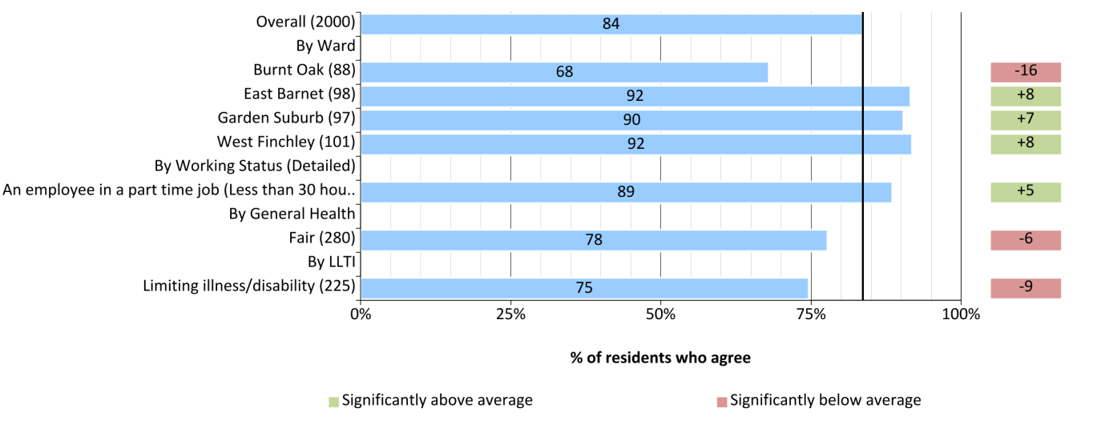

- Community cohesion remains high in Barnet with 84% of residents agreeing that people from different backgrounds get on well together in the borough and 78% of residents feel there is not a problem/not a very big problem with people not treating each other with respect and consideration.

- Overall the percentage of residents who agree that people from different backgrounds get on well together has improved by 1 percentage point since 2012 to 84% which is one percentage point short of the target to improve this measure by 2 percentage points.

- Within this overall measure there are some variations in perceptions. The data suggests that there are geographic differences in this perception with Garden Suburb, East Barnet and West Finchley showing more positive perception and residents in Burnt Oak ward showing a more negative perception at 68%.

- In addition health considerations appear to affect this perception with those in fair health or with a limiting long term illness or disability showing a reduced perception of -6% and -9% below the overall figure respectively.

- The Residents Perception Survey takes place twice yearly and it will be important to monitor these trends to understand how well different groups are getting along.

- The information will be shared with partners in Health and Regeneration and taken into account in broader participation and engagement strategies as we address the needs and aspirations of particular groups of Barnet citizens and particular locations.

3.2 The target set is to keep the % of residents who feel the council doesn’t do enough for people like me at 47% taking 2012 as the baseline.

 |  | 2012 |  | 2013  A great deal/to some extent | 2014  A great deal/to some extent | 2014 Responses | Variation from overall figures
 |  | % |  | % | % | Number | %
Overall |  | 47 |  | 51 | 55 | 1,993
By LLTI- limiting illness/ disability |  | 46* |  | 60 | 64* | 138 | +10
 |  |  | *Note: Last year's results did not return as statistically significant
Other significant data is outlined below:

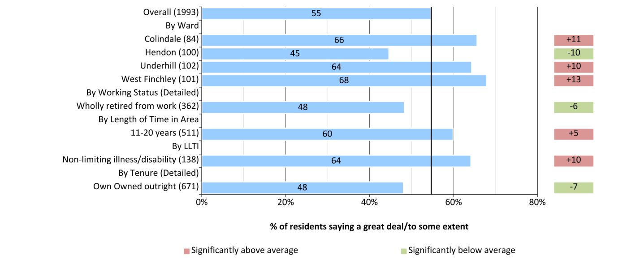
- The Spring 2014 Residents Perception Survey shows a continuing downward trend with 55% of residents now agreeing with this statement. This continues the recent downwards trend in perception; with an overall 8% percentage point increase when compared to 2012. Respondents with a limiting long term illness or disability responded even more negatively with an 18 percentage point downturn compared with 2012.
- This is in contrast with 87% of residents being satisfied with their local area as a place to live, 72% of residents being satisfied with how the council runs things and 76% of residents who feel the council is doing a good job.
- More detailed analysis of this measure indicates a10% increase for residents who have lived in the borough between 11- 20 years, a 6% increase for those who have lived in the borough for more than 21 years and an 8% increase amongst residents who have not contacted the council in the last year.
- There are geographical differences in this perception with Hendon, Colindale, West Finchley and Underhill showing a significant increase with this negative perception.
- Given sustained improvements in other aspects of Resident satisfaction, we are not happy with the direction of travel on Resident perception about whether the council does enough for people like me. This is showing increasing dissatisfaction when Barnet has set a target to maintain the level at 47%. We will continue to monitor this.

Cumulative Equalities Impact Analysis
- We try to understand the cumulative impact of our proposals on different groups, for example austerity, the rising cost of living and changes in public service provision.
- In February 2014 the council was obliged to find budget savings of £19.01m from a budget of 292, 984,580. In 2015/16 a further £20.082m savings must be achieved. The budget proposals tried to plan early for savings through efficiencies and to support the council priority to protect key front line services which respond to need. Equality Impact assessments were carried out for budget savings and consultation so that the council could pay due regard to equalities in decision making and to meet our responsibilities to the protected characteristics determined by the Equalities Act 2010. A cumulative impact assessment was also carried out which identified that the following groups were impacted by our proposals:
- Older people
- Younger people
- Disabled people including mental health problems
- Vulnerable groups
- Lone parents and some families
- Unemployed people
- People with a low income
The report can be found here: http://barnet.moderngov.co.uk/documents/s13303/App%20H%20i%20Cumulative%20EIA.pdf

Next Steps

We will continue our efforts to achieve our Strategic Equalities objective through our approach to provide equal opportunities and life chances for all and to publish information as we deliver accessible and value for money services which address disadvantage and respond to real needs.
The landscape for local authorities for the coming years shows clearly that further efficiencies will be required and the council is projecting that a further £70m of savings will be required by 2020. We have identified as a key priority the need for everybody to share the benefits from growth in local economy and we will work in partnership with all our Delivery units and all our strategic partners including health, Job centre plus, Re, our commercial partner, CAPITA and the West London Alliance.
This report will be shared with our partners and taken into account in broader participation and engagement strategies as we address the needs and aspirations of particular groups of Barnet citizens and particular locations.

