RENTAL DETAILS
Edgware Road/Geron Way – Vacant Premises
To Let (short term) – approx. 1.13 ha (approx. 2.8 acres)

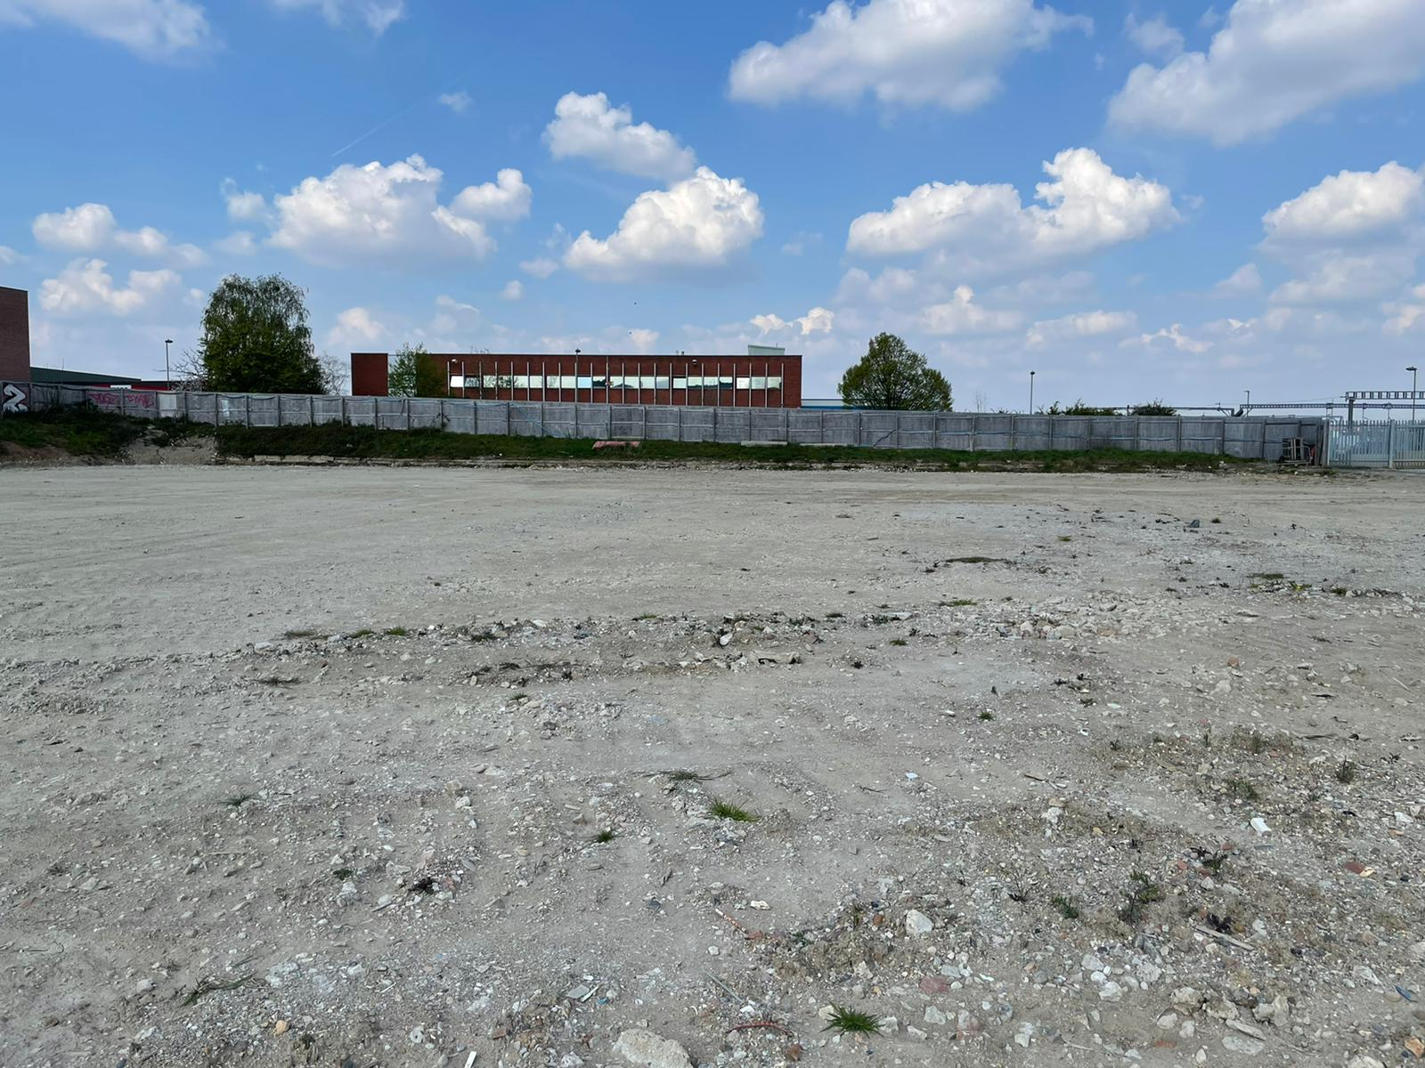

2 Geron Way, Brent Cross, Barnet, NW2 6GJ
*Cleared Site for Open Storage*

Location

This site is located on the Edgware Road (A5) in Brent Cross only 600m from access to the North Circular A406 and Junction 1 of the M1.

It is within close proximity of the new Brent Cross West Station (Thameslink), Staples Corner Retail Park, Decathlon and Builders Depot on the Edgware Road.

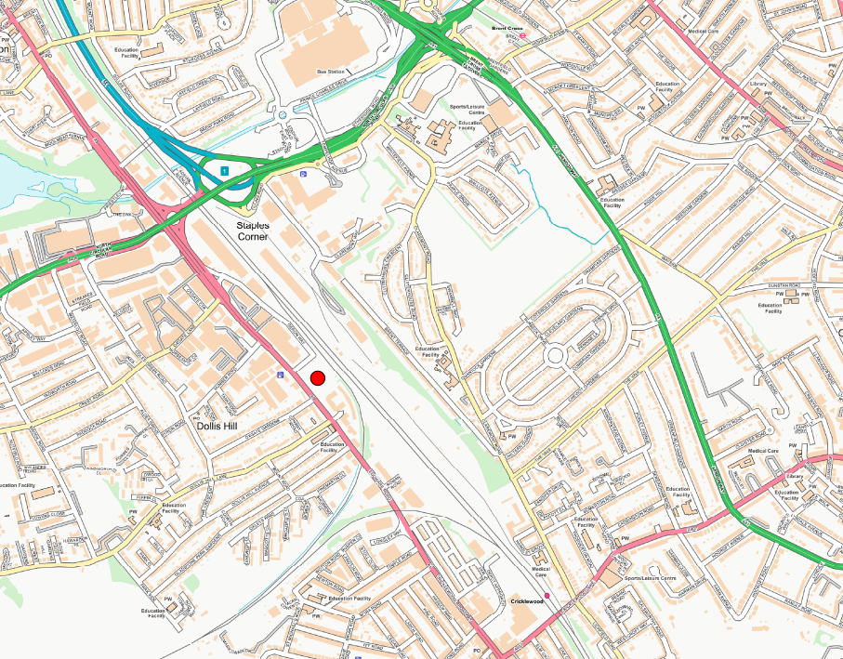

Site description
The site is surrounded by a hoarding with access from Geron Way former warehouse on the site has been demolished. The Edgware Road frontage is approximately 129m. The surface is compacted fill. Depending on the proposed use, some improvement works may be required.

Gas and Water are supplied to the site, but are currently capped off. Electricity provision is 140 KVa (200A) supply.

Rental terms
A 2 year lease agreement (Outside of the Landlord and Tenant Property Act 1954 Security of Tenure provisions) is available. This will be subject to a Landlord only break option at any time after 1 year (on 2 months notice).

The property is not currently rated, but the Tenant will be liable for business rates.

The lease will be granted subject to a Sub-station lease on part with UKPN, although the sub-station has been removed. More detail can be provided upon request.
Costs
The prospective tenant will be responsible for the council’s legal and surveyor’s fees.

Further Information please contact:
Barnet Estates/Property Services | Tel: 020 8359 3999  Email: Business.Space@barnet.gov.uk
General Information
1. The areas and measurements contained within these particulars are approximate figures only and no warranty is given as to their accuracy. The prospective tenants should satisfy themselves as to site areas and other matters of measurement from their own inspections and surveys. These details do not form part of any contract.
2. All statements made herein are made without responsibility on the part of the London Borough of Barnet and its employees and should not be relied upon as statements or representations of fact. Prospective tenants must satisfy themselves by inspection or otherwise as to the correctness of each of the statements contained in these particulars.
3. The London Borough of Barnet and its employees do not give any warranty whatsoever in relation to the property.
4. The property will be leased as seen with all latent and patent defects and neither the London Borough of Barnet nor its employees warrant that it is suitable for any proposed use.
5. In no case shall any prospective tenant have any claim for expenses incurred in the preparation of any offer, nor in respect of any other matter.
6. The Council is not obliged to accept the highest or any offer received.

